BUILDING AN ONLINE SHOE-SELLING WEBSITE

Software Requirements Specification
Version 3.0

Table Contents

1. DOCUMENT HISTORY 5
2. REFERENCE DOCUMENTS 5
3. DISTRIBUTION LIST AND APPROVALS 5
4. INTRODUCTION 6
5. OVERVIEW 7
5.1. Actors 7
5.2. System Use Case Diagram 9
5.2.1 Manage personal information 9
5.2.2 Guest, Customer 10
5.2.3 Content creator 11
5.2.4 Shipper 11
5.2.5 Seller, Store Administrator 12
6. FUNCTIONAL DESCRIPTION 13
6.1 Guest 13
6.1.1 Account registration 13
6.1.2 View products 15
6.1.3 Search product 17
6.1.4 Read content 18
6.1.5 Chat with the shop 20
6.2 Customer 22
6.2.1 Log in 22
6.2.2 Log out 25
6.2.3 Change password 26
6.2.4 Forgot password 29
6.2.5 View products 32
6.2.5 Search product 33
6.2.6 Read contents 35
6.2.8 Comment 36
6.2.9 View personal information 38
6.2.10 Update personal information 39
6.2.11 Purchase 41
6.2.12 Choose payment method 43
6.2.13 CRUD items in cart 44
6.2.14 View purchase history 46
6.2.15 Track order 47
6.2.16 Chat with the shop 49
6.2.17 View contact information 51
6.3 Content creator 53
6.3.1 Login 53
6.3.2 Logout 55
6.3.3 Change password 56
6.3.4 Forgot password 59
6.3.5 Read contents 62
6.3.6 View personal information 63
6.3.7 Update personal information 65
6.3.8 CRUD content 67
6.4 Shipper 71
6.4.1 Login 71
6.4.2 Logout 73
6.4.3 Change password 74
6.4.4 Forgot password 77
6.4.5 View personal information 80
6.4.6 Update personal information 82
6.4.7 Confirm order 83
6.4.8 View order details 85
6.4.9 Confirm delivery 88
6.4.10 Check failed delivery 91
6.4.11 View detail order history 93
6.5 Seller 95
6.5.1 Log in 95
6.5.2 Log out 97
6.5.3 Change password 98
6.5.4 Forgot password 101
6.5.5 View products 104
6.5.6 Search product 105
6.5.7 CRUD products 107
6.5.8 View order status 109
6.5.9 View sale history 111
6.5.10 View revenue statistic table 113
6.6 Store Administrator 115
6.6.1 Log in 115
6.6.2 Log out 118
6.6.3 Change password 119
6.6.4 Forgot password 122
6.6.5 View products 125
6.6.6 Search products 126
6.6.7 CRUD products 128
6.6.8 View order status 130
6.6.9 View sale history 133
6.6.10 View revenue 135
6.6.11 View detail order history 137
6.6.12 CRUD employees 139
7. NON-FUNCTIONAL REQUIREMENTS AND OTHERS 143
Performance 143
Scalability 143
Security 143
Browser 144
Reliability 144
Interfaces 144
Assumptions 144

1. DOCUMENT HISTORY
Date | Summary of Changes | Version
-05-2023 | - Draw a general use case diagram and assign work | 1.0
-05-2023 | - Describe the framework of the report and outline some of the functions | 1.0
-05-2023 | - Draw mockup for Admin page  - Fixed errors in GVHD comments | 2.0
-05-2023 | - Draw mockups for student and faculty pages  - Edit and finalize mockups. | 2.0
-05-2023 | - Finalize the report  - Fixing non-standard Usecases | 2.0
-05-2023 | - Edit and finalize the report | 2.0

2. REFERENCE DOCUMENTS
Document Name | Description
SRS_Templatev_1.0.docx | As a document of the GVHD FSOFT team, the content inside includes how to fully report the RMS model.

3. DISTRIBUTION LIST AND APPROVALS
Name | Title
Mai Văn Tâm | - Create general use cases.  - Create Usecases for the Store Administrators section.
Võ Ngọc Thành | - Write SRS documentation for the Store Administrators section.  - Create Usecases for Customer, Guest.
Trần Viết Ngọc Tâm | - Write SRS documents for Customer, Guest.  - Create Usecases for the Shipper section.
Trịnh Anh Quân | - Write the SRS document for the Shipper part.  - Create Usecases for Content Creator.
Trần Thị Trúc Mai | - Write the SRS document for the Content Creator section.  - Create Usecases for Seller section.  - Write SRS document for Seller section.

4. INTRODUCTION
4.1. Purpose
The purpose of this document is to provide a detailed description of the functionalities of the " Develop the website system for the online shoe store". It illustrates in detail the functions and constructs a complete system. It provides a clear explanation of the system's constraints, presents an overview of the interface, and the interactions with external systems or applications. This document is intended to present and discuss with the client for better editing and fine-tuning.

4.2. In scope
- The Hipster Shop is an e-commerce website that specializes in selling shoes. It offers various features to support customers throughout the buying and ordering process. This includes browsing the shoe catalog, searching for specific types or brands of shoes, viewing product images and descriptions, selecting sizes, and placing an order.

- The system serves six main user types:
- Guest
- Customer
- Shipper
- Content Creator
- Seller
- Store administrators
The website allows users to make purchases from the shop by logging in with their registered accounts. Once registered, users can proceed to shop for products. The website aims to provide a fast and reliable shopping experience for users when purchasing shoes.

5. OVERVIEW

5.1. Actors
The diagram below depicts all the actors involved in the "Develop the website system for the online shoe store" Each actor has a distinct role in the system, and the current actors are: Guest, Customer, Shipper, Content Creator, Seller, and Store Administrators.
Guest: A user who is not logged into their account on the shoe store website. Guests can view product listings and descriptions but cannot engage in shopping activities or manage their personal accounts.
Customer: A user who has registered an account on the shoe store website and can engage in shopping activities and manage their account.
Shipper: The person responsible for delivering orders from the shop to the customer's shipping address. They can update the delivery status of orders. Their account is authorized by Store Administrators.
Content Creator: The individual responsible for creating advertising content for products, including images and product descriptions. Their task is to attract customers to the products and help increase sales. Their account is authorized by Store Administrators.
Seller: The person responsible for providing detailed product information, managing orders, managing discount programs, and managing income. Their account is authorized by Store Administrators.
Store Administrators: Individuals who manage and operate the shoe store website. They have similar functions as sellers but also have the ability to grant permissions to other staff accounts.

Actor | Description
Guest | - Permit to visit the online store, view products, and read blog  - Deny to add products to the shopping cart, make payments, or leave comments,...
Customer | - Permit to manage their personal account  - Permit to participate in shopping activities
Shipper | - Permit to manage their personal account  - Permit to update the status of orders
Content Creator | - Permit to manage their personal account  - Permit to manage post
Seller | - Permit to manage their personal account  - Permit to manage orders  - Permit to manage discount programs  - Permit to manage income  - Permit to manage products
Store Administrators | - Permit to manage their personal account  - Permit to manage orders  - Permit to manage discount programs  - Permit to manage income  - Permit to manage products  - Permit to grant permissions to each staff role

5.2. System Use Case Diagram

5.2.1 Manage personal information

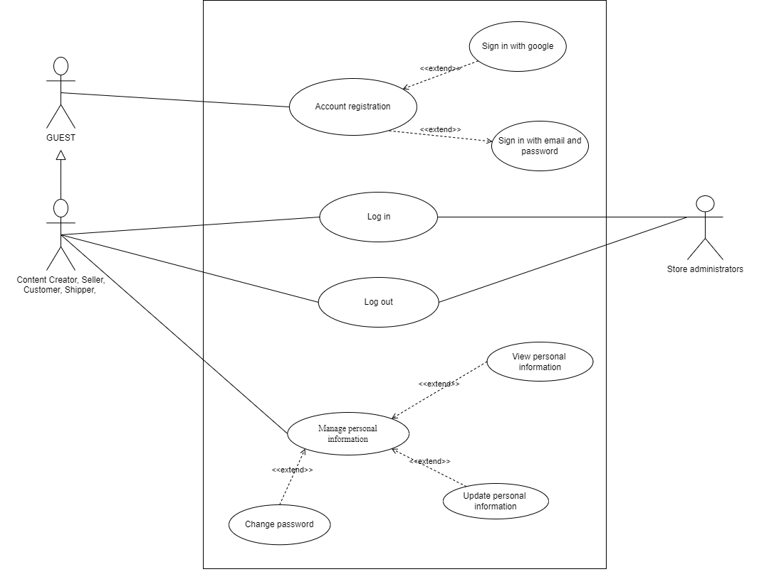

5.2.2 Guest, Customer
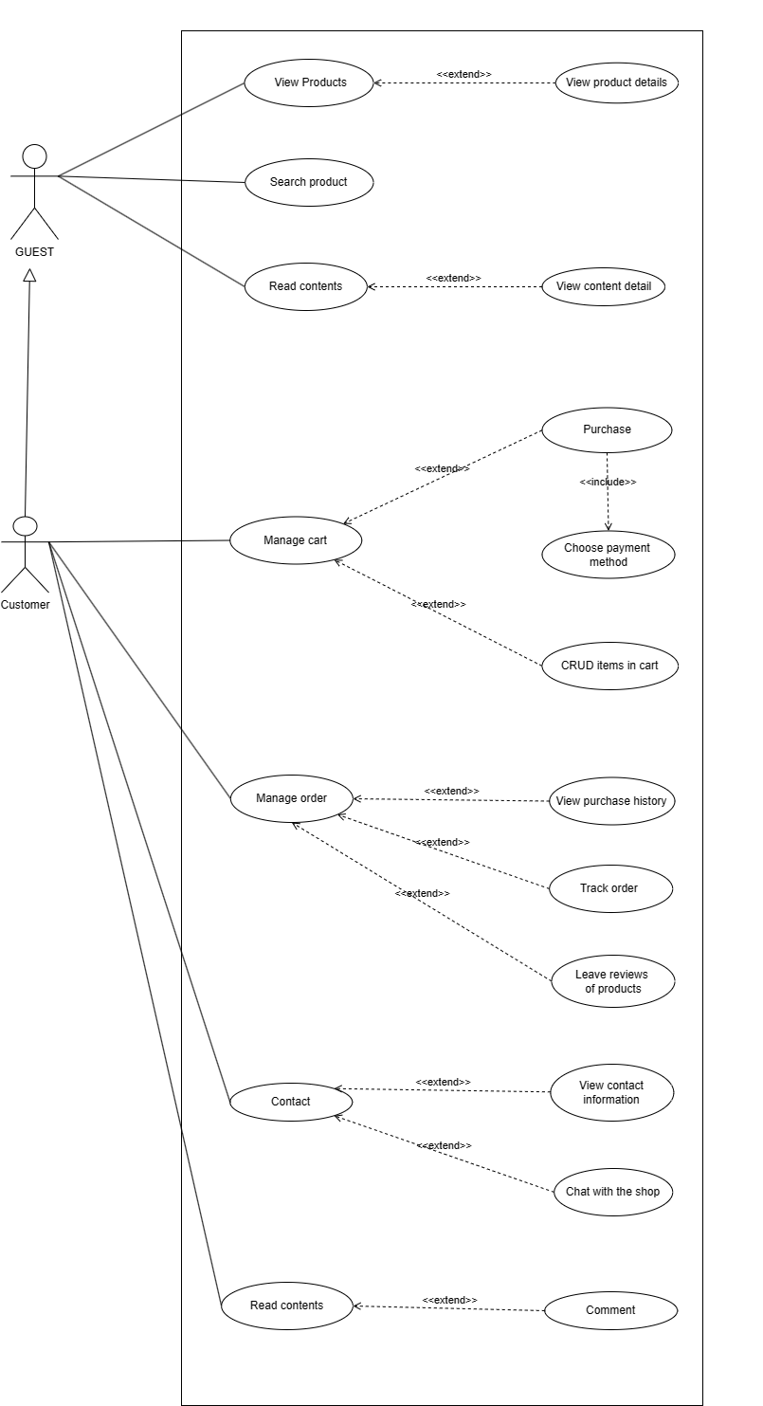

5.2.3 Content creator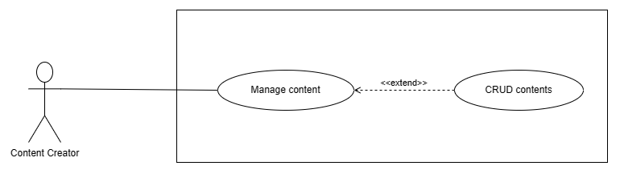

5.2.4 Shipper
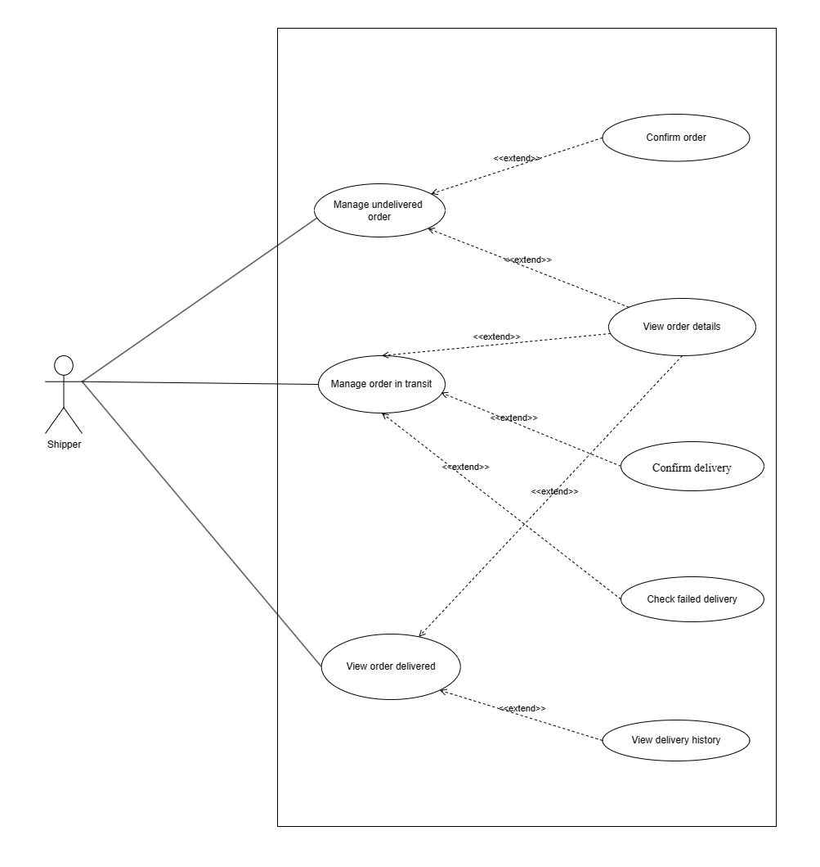

5.2.5 Seller, Store Administrator
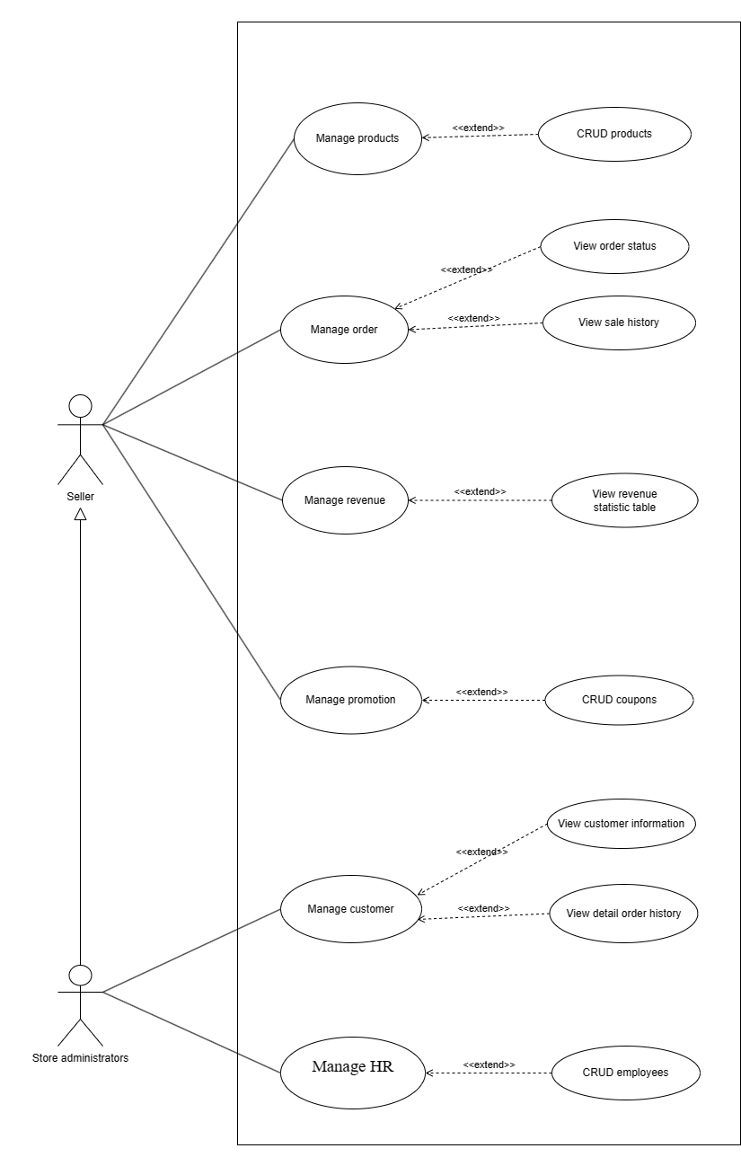

6. FUNCTIONAL DESCRIPTION

6.1 Guest

6.1.1 Account registration
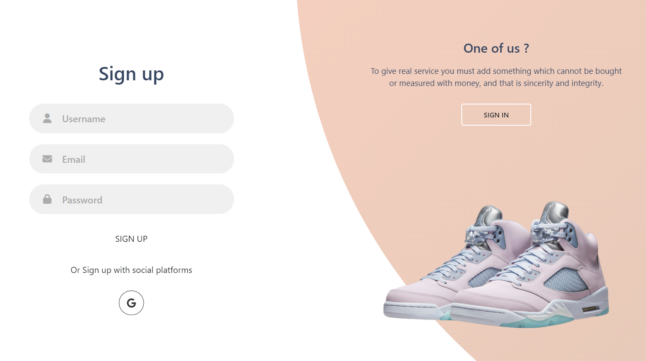
Screen | Account Registration
Description | Allow users to register for a store account
Screen Access | Guest visit to the homepage and click to icon , then click to the button “Sign up”
Screen Content
Item |  | Type | Data |  | Description
Username |  | Text field – String (50) |  |  | Enter the username field
Email |  | Text field – String (50) |  |  | Enter the email field
Password |  | Text field – String (50) |  |  | Enter the password field
Sign up |  | Button |  |  | Registration confirmation (Sign up button will be disabled until all the fields are fully entered)
Google login |  | Button |  |  | Sign up with a google account
Screen Actions
Action Name | Description |  |  | Success |  | Failure
Username | The user enters the account username to register an account in the shop. |  |  | Enter successfully. |  | If the user leaves this field blank, it will return a message asking the user to enter this field.  If the account already exists a username in the database will ask the user to re-enter that username, so that it is different from the username already in the store.
Email | The user enters the account email to register an account in the shop. |  |  | Enter successfully. |  | If the user leaves this field blank, it will return a message asking the user to enter this field.  If the account already exists, an email in the database will ask the user to re-enter that email, so that it is different from the email already in the store.
Password | The user enters the account password to register an account in the shop |  |  | Enter successfully |  | If the user leaves this field blank, it will return a message asking the user to enter this field.  It is required to enter the correct password setting rules

6.1.2 View products
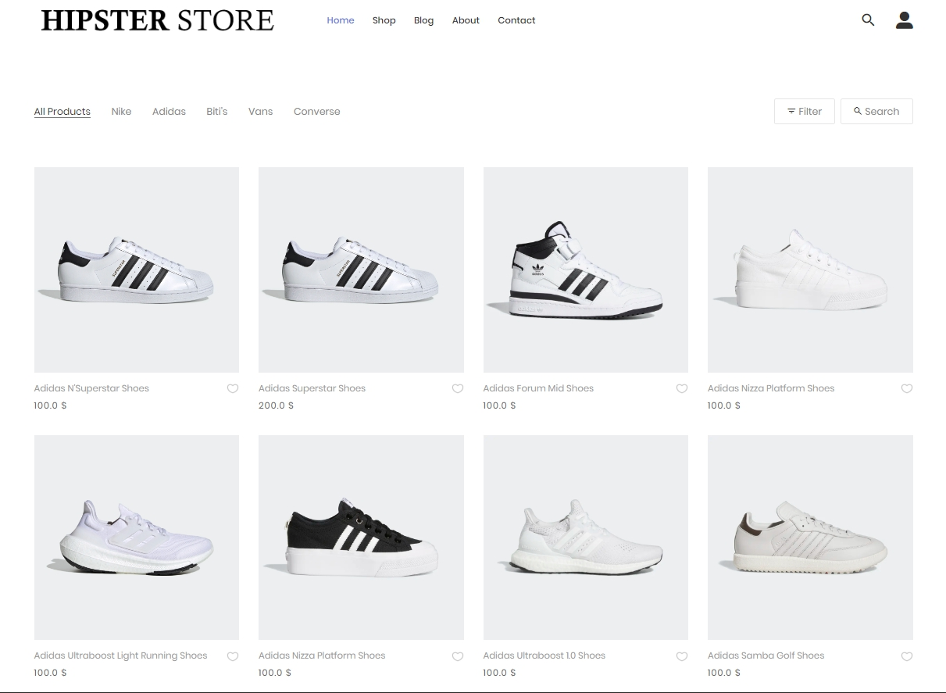

Screen | View products
Description | View the products of the shop
Screen Access | User visits the store's website and clicks on Products
Screen Content
Item |  | Type | Data |  | Description
Product |  | Button |  |  | View all products in the shop
Screen Actions
Action Name | Description |  |  | Success |  | Failure
Product | When the user clicks on the Product icon, a Product page will appear containing all the products in the shop's website |  |  | The system returns the product page |  | When there is a database connection error -> Show the message "Connection failed".  The screen still shows the current page.

6.1.3 Search product
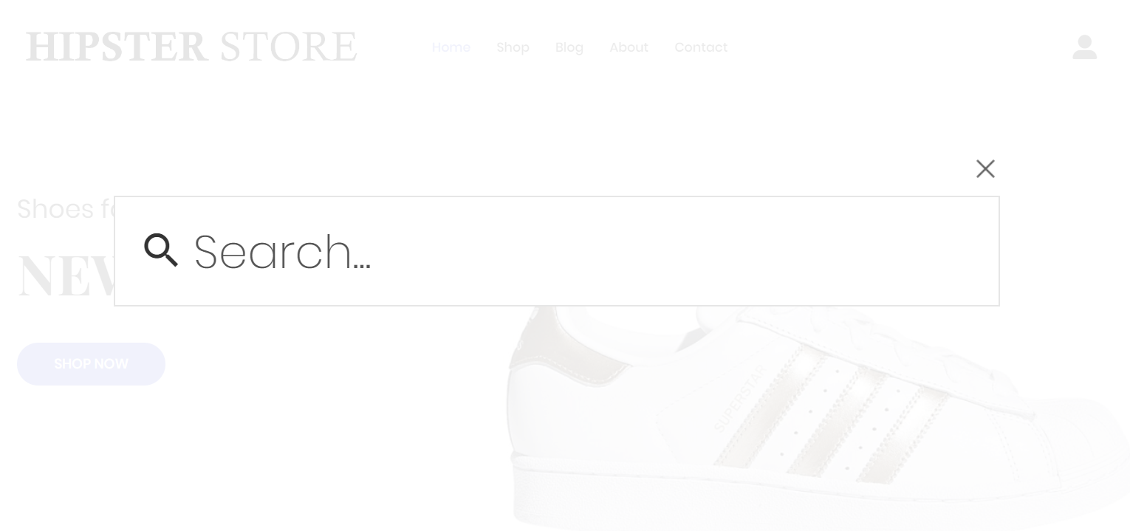
Screen | Search products
Description | Search for products in the shop
Screen Access | User visits the store's website and clicks on Search
Screen Content
Item |  | Type | Data |  | Description
Search products |  | Button |  |  | Users want to search for products in the shop
Search |  | Text field – String (50) |  |  | Enter the product the user wants to search for
Screen Actions
Action Name | Description |  |  | Success |  | Failure
Search products | Users click on the search button icon to search for products in the shop |  |  | The system will return an Alerts message, for the user to enter the product to look for |  | System error cannot be displayed  Mô tả nếu để trống sẽ để lại mô tả cũ.
Search | The user will enter the product they want to find on the shop's website |  |  | Returns displays the product the person wants to search for |  | Product not found error

6.1.4 Read content
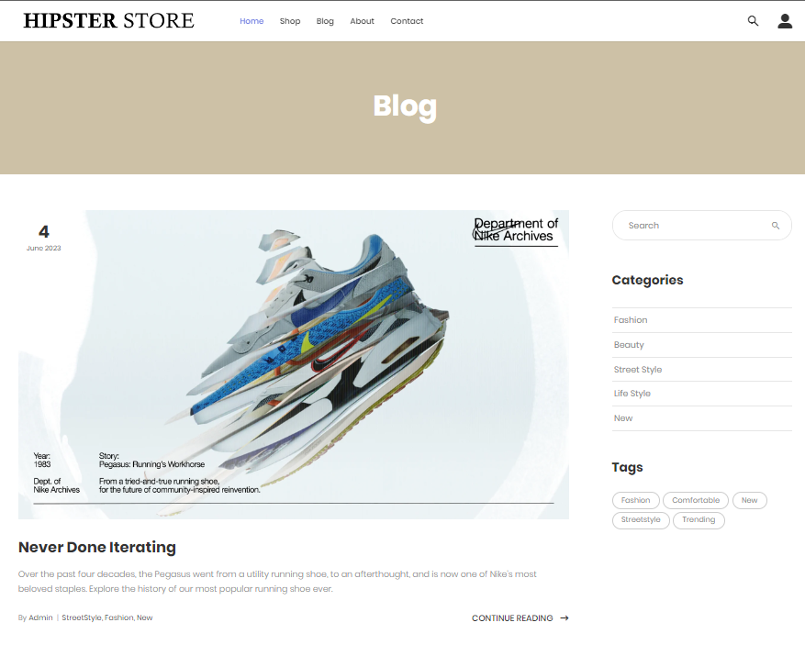

Screen | Read contents
Description | Users want to read the content of the shop website
Screen Access | User visits the store's website and clicks on Blog
Screen Content
Item |  | Type | Data |  | Description
Blog |  | Button |  |  | See all the contents of the shop's website
Screen Actions
Action Name | Description |  |  | Success |  | Failure
Blog | When the user clicks on the Blog icon, a Blog page will appear containing all the content in the shop's website |  |  | The system returns the blog page |  | When there is a database connection error -> Show the message "Connection failed".  The screen still shows the current page.

6.1.5 Chat with the shop
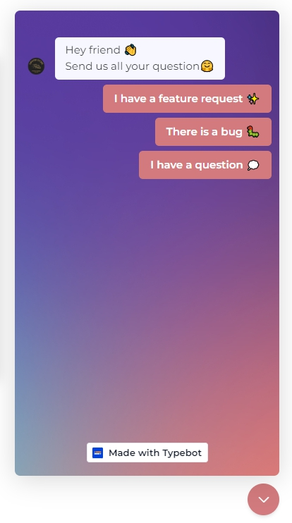
Screen | Use chatbot to support user
Description | Allows users to report bugs or communicate with administrators.
Screen Access | Click on the chatbot logo in the lower right corner
Screen Content
Item |  | Type | Data |  | Description
Chat window |  | Floating Chat Window |  |  | Display the ongoing conversation between the user and the chatbot
Text input field |  | Text field |  |  | The user can input their messages or queries into the text input field located at the bottom of the chat window
Response of chatbot |  | Text field |  |  | The chatbot's responses appear as text messages within the chat window. They are typically displayed in a distinctive style or with a different color to differentiate them from user messages
Cancel |  | Button |  |  | Close the chat
Screen Actions
Action Name | Description |  |  | Success |  | Failure
Cancel | When clicking the cancel button, the chat frame will shrink, only showing the chatbot logo |  |  | Still on the current accessed page |  | The user can continue sending new requests or messages to the chatbot, or they can find other ways to exit the chatbot interface, such as closing the browser or locating other exit buttons on the interface
Chat | Clicking on the chat box opens the text input field, allowing the user to start chatting with the chatbot |  |  | The chatbot responds to what the user wants accurately |  | Misunderstanding the user's input, the chatbot may provide inaccurate or unrelated responses

6.2 Customer

6.2.1 Log in
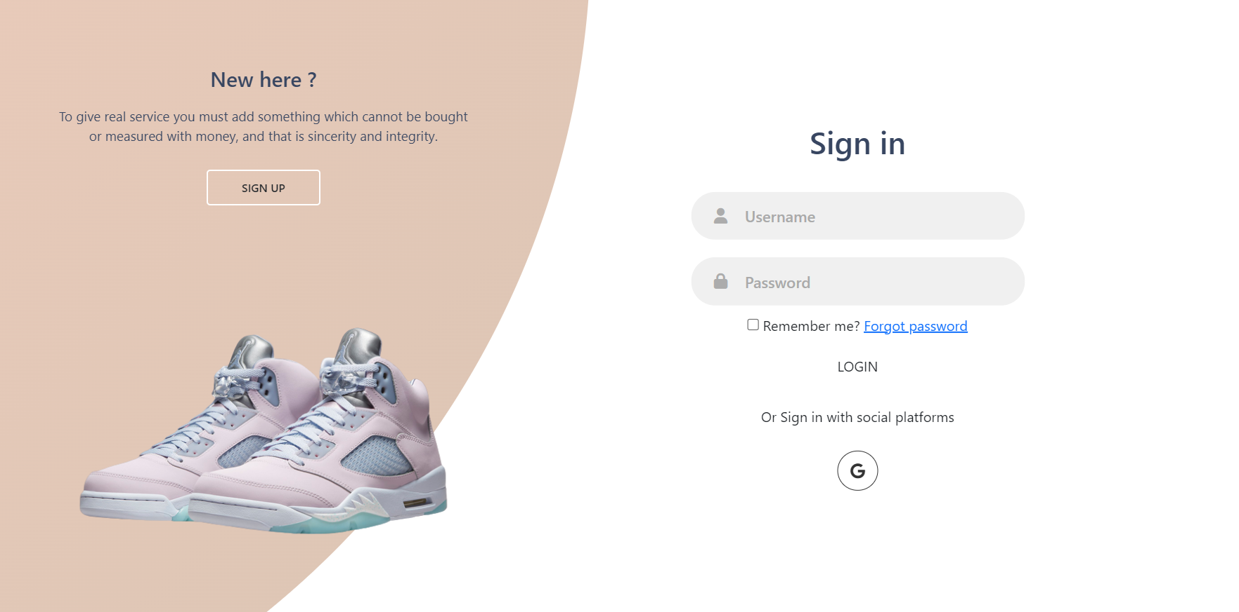
Screen | Log in
Description | Allow users to log in for a store account.
Screen Access | Click on the registration and login icon on the homepage of the shop website.
Screen Content
Item |  | Type | Data |  | Description
Username |  | Text field – String (50) |  |  | Enter the username field
Password |  | Text field – String (50) |  |  | Enter the password field
Login |  | Button |  |  | Login account to the shop's system.
Google login |  | Button |  |  | Sign up with a google account
Screen Actions
Action Name | Description |  |  | Success |  | Failure
Username | The user enters the account username to log in to an account in the shop. |  |  | Enter successfully. |  | If the user leaves this field blank, it will return a message asking the user to enter it.
Password | The user enters the account password to log in to an account in the shop. |  |  | Enter successfully. |  | If the user leaves this field blank, it will return a message asking the user to enter it.
Log in | This is the button to confirm the account login at the shop. |  |  | Display a successful registration message. |  | When the user enters incomplete fields, a message will be displayed asking the user to enter the fields that have not been documented.  If the user enters the wrong password or username, a message will be displayed asking the user to enter the correct username and password of the login name.
Google login | Login with a Google account. |  |  | Display the login page with Google and confirm the login account |  | If the logged-in Gmail has not registered an account in the shop's database, it will display a message that Gmail is not registered and ask the user to log in with another Google account.

6.2.2 Log out
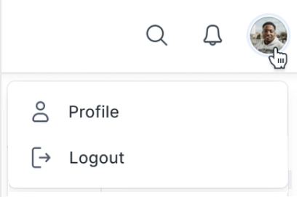
Screen | Log out
Description | The user wants to log out of account on the store's website
Screen Access | Click on the login icon on the homepage of the shop website.
Screen Content
Item |  | Type | Data |  | Description
Account information |  | Button |  |  | User's account information
Logout |  | Button |  |  | Log out account
Screen Actions
Action Name | Description |  |  | Success |  | Failure
Account information | Show all user information |  |  | Successfully. |  | System error cannot be displayed
Logout | The user wants to log out of the shop's website system. |  |  | Logout successfully. |  | System error cannot be displayed

6.2.3 Change password
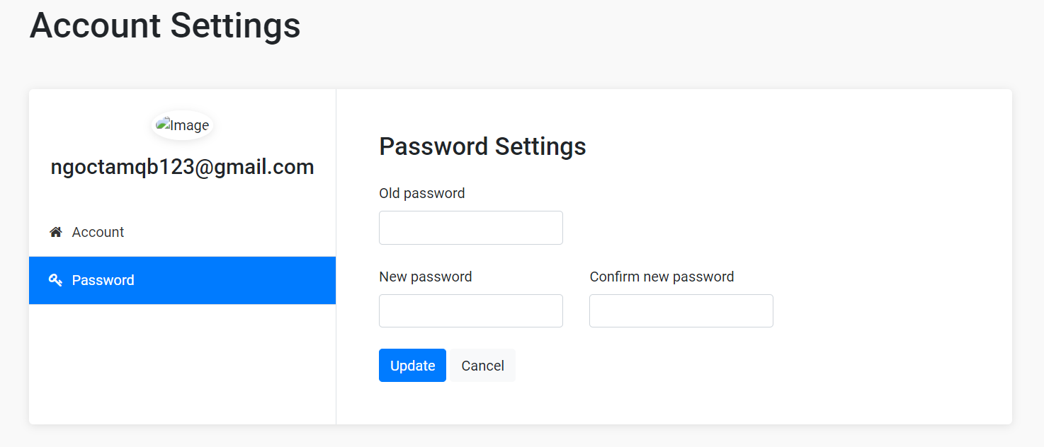

Screen | Change password
Description | The user wants to change the password.
Screen Access | Click on the profile account icon and select my account, and continue to select change password.
Screen Content
Item |  | Type | Data |  | Description
Old password |  | Text field – String (50) |  |  | Requires the user's old password.
New password |  | Text field – String (50) |  |  | Requires the user's new password.
Confirm new password |  | Text field – String (50) |  |  | Requires the user to re-enter the correct new password
Save |  | Button |  |  | Confirm to save updated password information
Screen Actions
Action Name | Description |  |  | Success |  | Failure
Old password | The user enters the old password registered for the shop account, this is a required field |  |  | Enter successful |  | If this field is left blank, a message will be displayed asking the user to enter  If the user does not enter the correct old password, a message will appear asking the user to enter the correct password registered at the shop's website.
New password | Enter the new password that the user wants to change the old password registered for the shop account, this is a required field |  |  | Enter successful |  | If this field is left blank, a message will be displayed asking the user to enter  Requires enter using password forma
Confirm new password | Confirm the password you want to change |  |  | Enter successful |  | If this field is left blank, a message will be displayed asking the user to enter  When the user enters the confirmation password, enter the correct new password that the user wants to change
Save | Save update new password for account |  |  | New password saved successfully |  | When the user enters the missing field, a message will be displayed asking the user to enter all information  Request enter the correct old password and confirm the correct new password

6.2.4 Forgot password
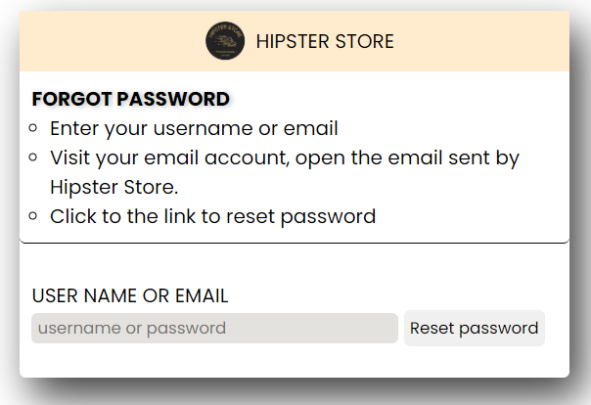

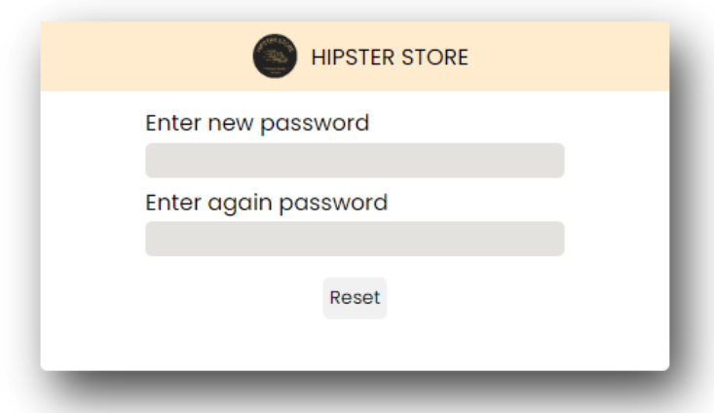

Screen | Forgot password
Description | User forgot password
Screen Access | Click on the login icon and continue to click on Forgot password
Screen Content
Item |  | Type | Data |  | Description
Forgot password |  | Button |  |  | The user forgot the shop's account password
Reset Password |  | Button |  |  | Change the password that the customer has forgotten
Enter email or username |  | Text field – String (50) |  |  | New password will be sent via registered email
Screen Actions
Action Name | Description |  |  | Success |  | Failure
Forgot password | The user forgot the password of the shop's website account and wants to recover the password |  |  | Information Confirmation: Users enter their username or email and click "Reset password." The system verifies if the entered information matches any account in the system. If the information is valid, the password recovery process continues. Password Reset Link: A password reset email containing a unique link is sent to the provided email address. The link typically has a limited validity period, such as 24 hours, to ensure security. Users need to check their inbox, access the email, and click the password reset link. Password  -After confirming, an email message has been sent and asks the user to confirm |  | A message appears in the upper corner of the screen when entering an exception "Please re-enter the field"
Reset Password | The final step to change the password when the customer forgets the old account after clicking on the confirmation link in the mail. |  |  | - Reset Page: Clicking the password reset link redirects users to a dedicated password reset page. This page prompts users to enter a new password. Sometimes, the system may also require users to confirm the new password by re-entering it. This ensures accuracy when setting a new password. New Password Confirmation: After entering and confirming the new password, users are directed to a confirmation page. This page informs users that their password has been successfully reset and provides instructions on using the new password to log in. |  | A message appears in the upper corner of the screen when entering an exception "Please re-enter the field"

6.2.5 View products

Screen | View products
Description | View the products of the shop
Screen Access | User visits the store's website and clicks on Products
Screen Content
Item |  | Type | Data |  | Description
Product |  | Button |  |  | View all products in the shop
Screen Actions
Action Name | Description |  |  | Success |  | Failure
Product | When the user clicks on the Product icon, a Product page will appear containing all the products in the shop's website |  |  | The system returns the product page |  | When there is a database connection error -> Show the message "Connection failed".  The screen still shows the current page.

6.2.5 Search product
Screen | Search products
Description | Search for products in the shop
Screen Access | User visits the store's website and clicks on Search
Screen Content
Item |  | Type | Data |  | Description
Search products |  | Button |  |  | Users want to search for products in the shop
Search |  | Text field – String (50) |  |  | Enter the product the user wants to search for
Screen Actions
Action Name | Description |  |  | Success |  | Failure
Search products | Users click on the search button icon to search for products in the shop |  |  | The system will return an Alerts message, for the user to enter the product to look for |  | System error cannot be displayed  Description of left blank will re-describe the old description.
Search | The user will enter the product they want to find on the shop's website |  |  | Returns displays the product the person wants to search for |  | Product not found error

6.2.6 Read contents
Screen | Read contents
Description | Users want to read the content of the shop website
Screen Access | User visits the store's website and clicks on Blog
Screen Content
Item |  | Type | Data |  | Description
Blog |  | Button |  |  | See all the contents of the shop's website
Screen Actions
Action Name | Description |  |  | Success |  | Failure
Blog | When the user clicks on the Blog icon, a Blog page will appear containing all the content in the shop's website |  |  | The system returns the blog page |  | When there is a database connection error -> Show the message "Connection failed".  The screen still shows the current page.

6.2.8 Comment
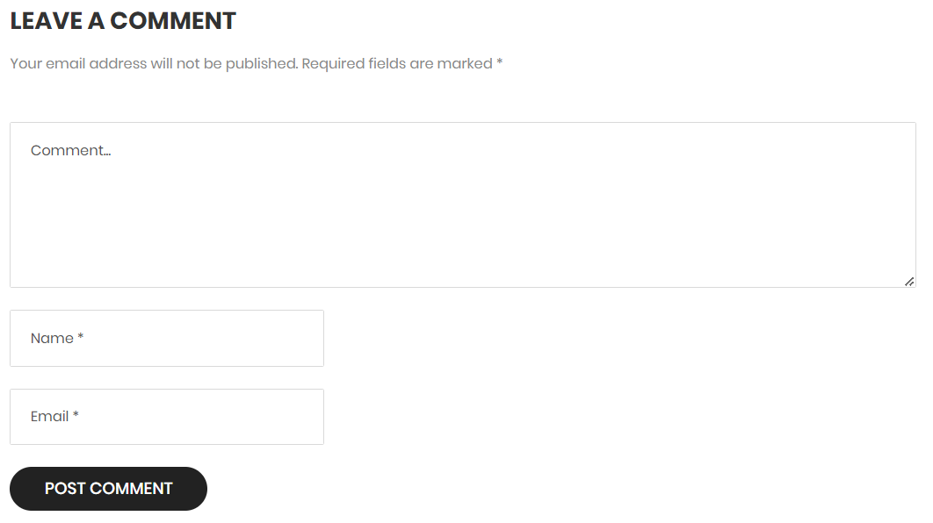
Screen | Comment
Description | Users want to comment on the products of the shop's website
Screen Access | Click on reading content on the Blog page of the shop website.
Screen Content
Item |  | Type | Data |  | Description
Comment |  | Text field – String (255) |  |  | Enter the text comment
Send comment |  | Button |  |  | Submit a comment
Screen Actions
Action Name | Description |  |  | Success |  | Failure
Comment | User wants to post a comment in the shop website |  |  | Enter content successfully |  | The user leaves this field blank, the system will send a request to enter the comment content
Send comment | The user wants to submit the content of the comment wrote |  |  | Send comment successfully |  | When there is a database connection error -> Show the message "Connection failed".  The screen still shows the current page.

6.2.9 View personal information
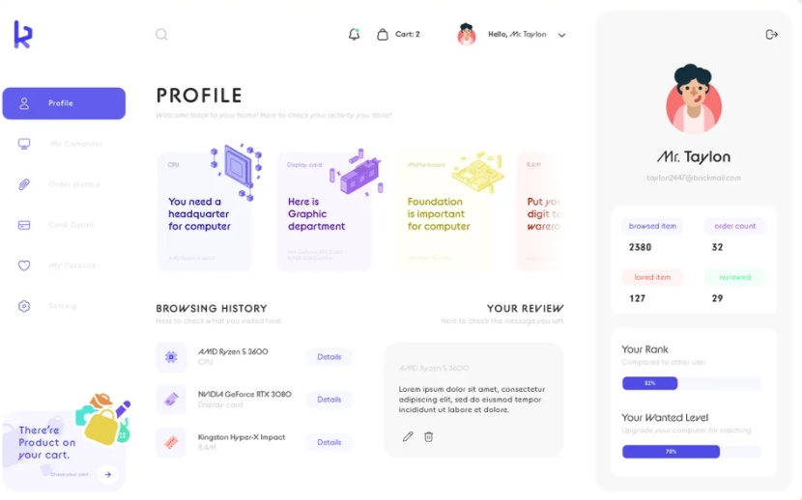
Screen | Personal information management
Description | Allow users to view registered personal information
Screen Access | Click on the link “Personal information” to go to the screen
Screen Content
Item |  | Type | Data |  | Description
User name |  | Text-nvarchar(50) |  |  | Display the user's username
Email |  | Text-nvarchar(50) |  |  | Show user's email
Fullname |  | Text-nvarchar(50) |  |  | Display the user's full name
Phone |  | Text-nvarchar(50) |  |  | Display the user's phone number
Address |  | Text-nvarchar(50) |  |  | Display the user's address
Screen Actions
Action Name | Description |  |  | Success |  | Failure
Change | When selecting "Change", the system will switch to the function of updating customer information |  |  | Go to the customer information edit page |  | When there is a database connection error -> Show the message “Failed to connect to the database".  The screen still shows the current page.

6.2.10 Update personal information
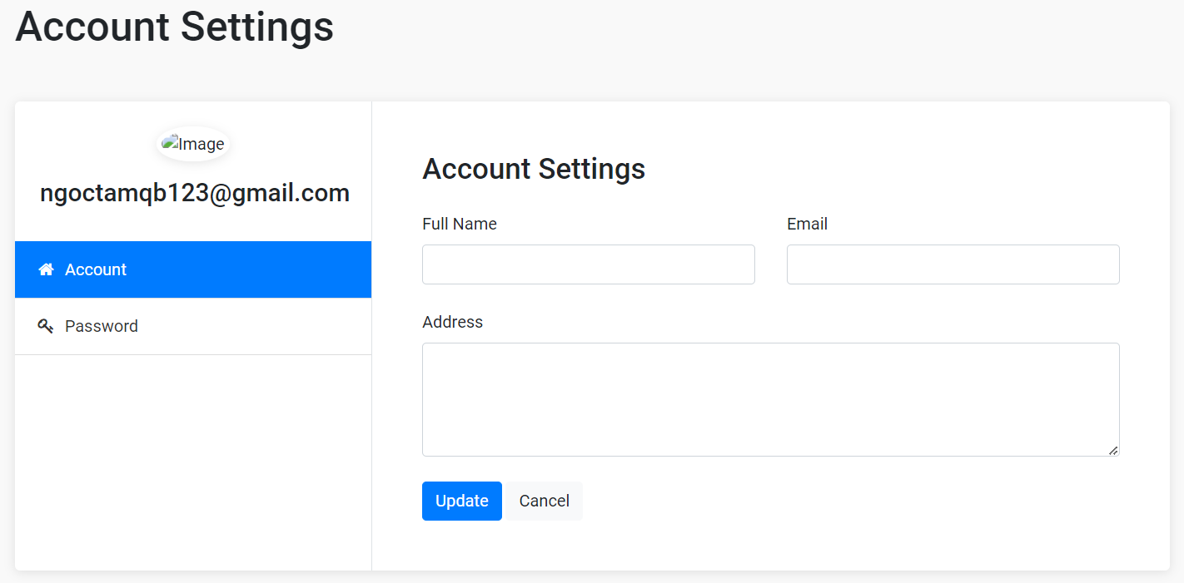
Screen | Change details of customer information
Description | Allow customers to change the information declared when registering
Screen Access | Click on the user icon in the top right corner
Screen Content
Item |  | Type | Data |  | Description
User name |  | Text-nvarchar(50) |  |  | Display the user's username
Email |  | Text-nvarchar(50) |  |  | Show user's email
Fullname |  | Text-nvarchar(50) |  |  | Display the user's full name
Phone |  | Text-nvarchar(50) |  |  | Display the user's phone number
Address |  | Text-nvarchar(50) |  |  | Display the user's address
User name |  | Text-nvarchar(50) |  |  | Display the user's username
Email |  | Text-nvarchar(50) |  |  | Show user's email
Screen Actions
Action Name | Description |  |  | Success |  | Failure
Save | When the user selects "Save", the system checks the conditions and modifies the data of the selected edited data in the database. |  |  | Return to the home page and notice: Edit successful. |  | Display edited fields with the wrong data type and notify the screen if an error occurs

6.2.11 Purchase
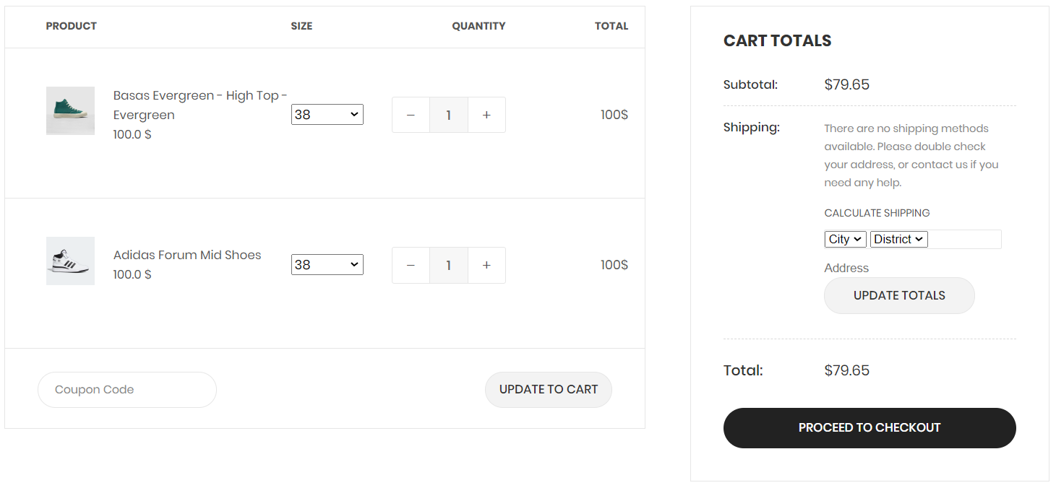
Screen | Payment of orders
Description | Allow users to pay for orders in the shopping cart
Screen Access | Click on the Cart icon in the right corner of the navigation bar
Screen Content
Item |  | Type | Data |  | Description
Product's name |  | Text field – String (50) |  |  | Show product name
Quantity |  | Number |  |  | Allow users to update the quantity they want to buy
Price |  | Text field – String (50) |  |  | Display the selling price of the product
Total |  | Text field – String (50) |  |  | Show total order value
Address |  | Text field – String (50) |  |  | Let users update order address
Update order |  | Button |  |  | Check the database and user side changes and update the total price
Product picture |  | Image |  |  | Show pictures of products
Screen Actions
Action Name | Description |  |  | Success |  | Failure
Select product | When a customer wants to buy individual products in the order, click on the background of that product line |  |  | Product background changes color darker and prices are updated |  | Display a message if an error is detected during execution
Pay | When the customer wants to complete the order process, click the "Checkout" button. |  |  | The order will be removed from the shopping cart and changed to "processing" status. |  | The order cannot be deleted and the screen prints an error during checkout
Delete | When a customer wants to remove an item from the cart |  |  | The order will be removed from the cart |  | Error message if deletion is not successful

6.2.12 Choose payment method
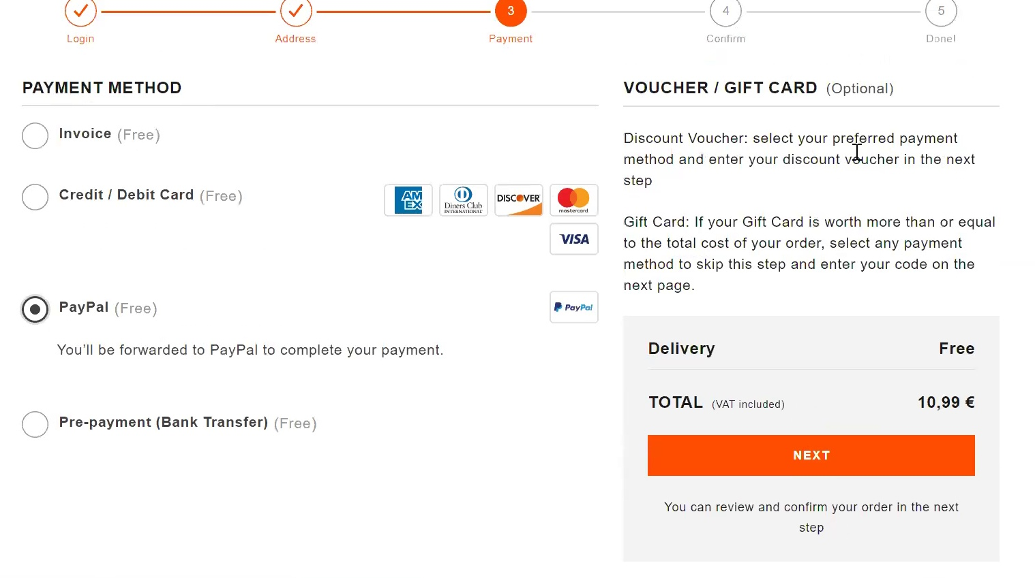

Screen | Select payment method
Description | Allow users to choose payment methods for orders
Screen Access | Click on cart and choose payment method
Screen Content
Item |  | Type | Data |  | Description
Payment methods |  | Text field – String (50) |  |  | Show applicable payment methods
Select |  | Button |  |  | Select a payment method
Confirm |  | Button |  |  | Agree to choose the payment method
Screen Actions
Action Name | Description |  |  | Success |  | Failure
Confirm | When the user clicks on confirm, the order will be paid according to the selected method. |  |  | The problem with the order screen with the payment method is the payment method that the customer chooses. |  | Error when choosing payment methods when user enters wrong payment information including card number, expiration date, OTP code. Display a message on the screen "Invalid payment method".

6.2.13 CRUD items in cart
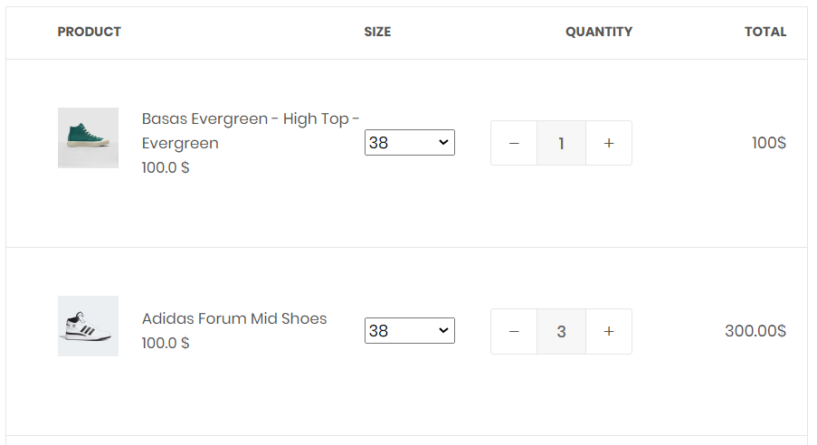
Screen | Add, edit, delete products in cart
Description | Allows users to influence the products in the shopping cart
Screen Access | Click on the shopping cart icon in the top right corner of the navigation bar
Screen Content
Item |  | Type | Data |  | Description
Product's name |  | Text field – String (50) |  |  | Show product name
Quantity |  | Number |  |  | Allow users to update the quantity they want to buy
Price |  | Text field – String (50) |  |  | Display the selling price of the product
Total |  | Text field – String (50) |  |  | Show total order value
Address |  | Text field – String (50) |  |  | Let the user update the order address
Update order |  | Button |  |  | Check the database and user side changes and update the total price
Screen Actions
Action Name | Description |  |  | Success |  | Failure
Select product | When a customer wants to buy individual products in the order, click on the background of that product line |  |  | Product background changes color darker and prices are updated |  | Display a message if an error is detected during execution
Pay | When the customer wants to complete the order process, click the "Checkout" button. |  |  | The order will be removed from the shopping cart and changed to "processing" status. |  | The order cannot be deleted and the screen prints an error during checkout
Delete | When a customer wants to remove an item from the cart |  |  | The order will be removed from the cart |  | Error message if deletion is not successful

6.2.14 View purchase history
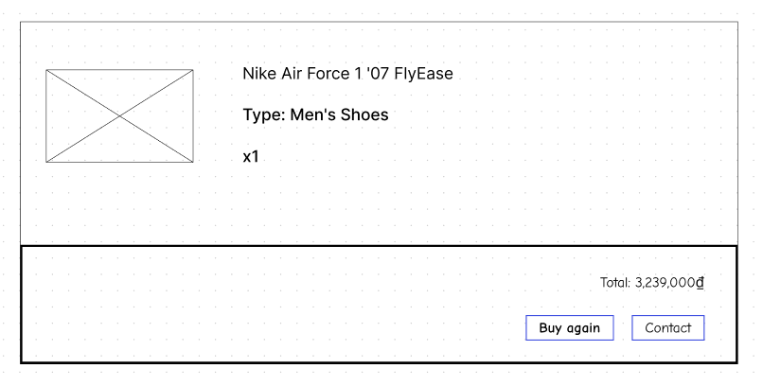
Screen | View payment history
Description | Allow customers to view individual payment history
Screen Access | Click on the user icon in the right corner, select the "view purchase history" feature in the navigation bar
Screen Content
Item |  | Type | Data |  | Description
Code orders |  | Text field – String (50) |  |  | Show order number
Name items |  | Text field – String (50) |  |  | Show item name
Price |  | Text field – String (50) |  |  | Show order price
Purchase date |  | Text field – String (50) |  |  | Show purchase date
Screen Actions
Action Name | Description |  |  | Success |  | Failure
See details | When the user clicks on “View details”, the order details are displayed according to the set code of that order |  |  | Go to the page displaying the details and complete information of the order placed |  | Error message cannot display information and return to the main page of the feature

6.2.15 Track order
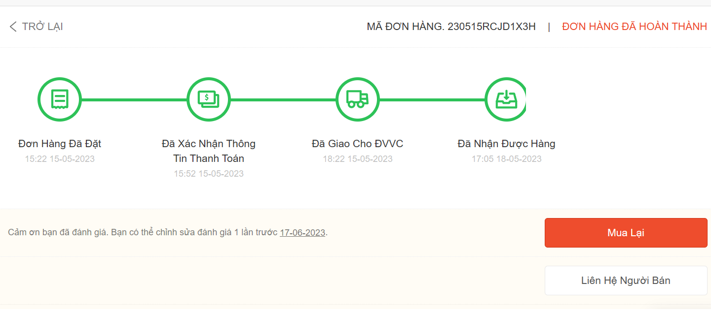
Screen | Check Order Status
Description | Allows customers to track the status of their orders.
Screen Access | Click on the user icon and select the "Track Order" feature.
Screen Content
Item |  | Type | Data |  | Description
Order Name |  | Text field – String (50) |  |  | Contains the name of the order.
Address |  | Text field – String (50) |  |  | Order address.
Price |  | Text field – String (50) |  |  | Price of the order.
Order Status |  | Text field – String (50) |  |  | Displays the status of the order.
Screen Actions
Action Name | Description |  |  | Success |  | Failure
View Details | When the user clicks on "View Details," they will see the detailed information of the selected order. |  |  | Go to the order detail page and display all the relevant information. |  | Display an error message on the screen and return to the main screen.

6.2.16 Chat with the shop

Screen | Using chatbots to support users
Description | Allows users to report bugs or communicate with administrators
Screen Access | Click on the chatbot logo in the lower right corner
Screen Content
Item |  | Type | Data |  | Description
Chat window |  | Floating Chat Window |  |  | Show ongoing conversation between user and chatbot
Text input field |  | Text field |  |  | Users can enter their message or query in the text input field located at the bottom of the chat window.
Feedback of chatbots |  | Text field |  |  | The chatbot's response appears as a text message in the chat window. They are often displayed in a special style or in a different color to distinguish them from user notifications.
Cancel |  | Button |  |  | Close the chat
Screen Actions
Action Name | Description |  |  | Success |  | Failure
Cancel | When clicking the cancel button, the chat frame will shrink, only showing the chatbot logo |  |  | Still on the current page |  | Users can continue to send new requests or messages to the chatbot or can find other ways to exit the chatbot interface, such as closing the browser or finding another exit button on the interface.
Chat | Click on the chat box as the text input field, start chatting with the chatbot |  |  | Chatbot responds exactly what the user wants |  | Misinterpreting user input, chatbots can give incorrect or irrelevant responses.

6.2.17 View contact information
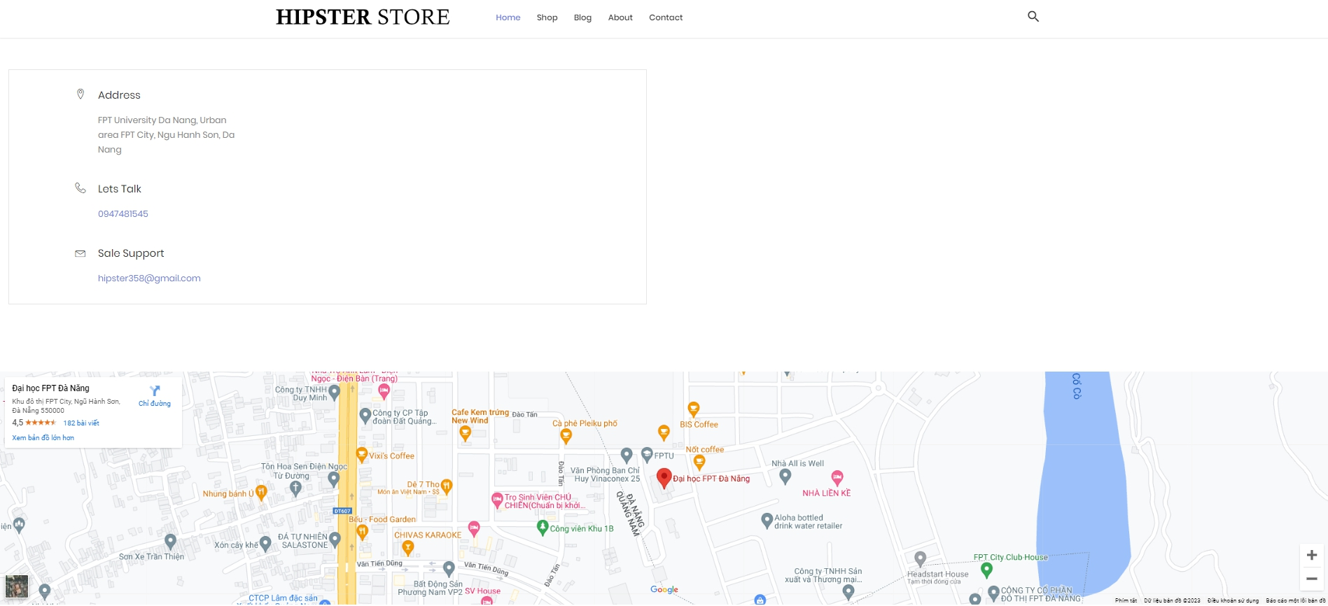
Screen | Show store information
Description | Allows users to view the store's address and contact information
Screen Access | Click on 'Contact' on the Home page
Screen Content
Item |  | Type | Data |  | Description
Contact |  | Button |  |  | Show contact information and address on the store's map
Screen Actions
Action Name | Description |  |  | Success |  | Failure
Contact | When the user clicks on 'Contact' on the Home page, the system will navigate to the Contact page |  |  | Switch to the contact page and display the store's information |  | When there is a database connection error -> Show the message "Connection failed".  The screen still shows the current page.

6.3 Content creator

6.3.1 Login
Screen | Log in
Description | Allow users to log in for a store account.
Screen Access | Click on the registration and login icon on the homepage of the shop website.
Screen Content
Item |  | Type | Data |  | Description
Username |  | Text field – String (50) |  |  | Enter the username field
Password |  | Text field – String (50) |  |  | Enter the password field
Login |  | Button |  |  | Login account to the shop's system.
Google login |  | Button |  |  | Sign up with a google account
Screen Actions
Action Name | Description |  |  | Success |  | Failure
Username | The user enters the account username to log in to an account in the shop. |  |  | Enter successfully. |  | If the user leaves this field blank, it will return a message asking the user to enter it.
Password | The user enters the account password to log in to an account in the shop. |  |  | Enter successfully. |  | If the user leaves this field blank, it will return a message asking the user to enter it.
Log in | This is the button to confirm the account login at the shop. |  |  | Display a successful registration message. |  | When the user enters incomplete fields, a message will be displayed asking the user to enter the fields that have not been documented.  If the user enters the wrong password or username, a message will be displayed asking the user to enter the correct username and password of the login name.
Google login | Login with a Google account. |  |  | Display the login page with Google and confirm the login account |  | If the logged-in Gmail has not registered an account in the shop's database, it will display a message that Gmail is not registered and ask the user to log in with another Google account.

6.3.2 Logout
Screen | Log out
Description | The user wants to log out of account on the store's website
Screen Access | Click on the login icon on the homepage of the shop website.
Screen Content
Item |  | Type | Data |  | Description
Account information |  | Button |  |  | User's account information
Logout |  | Button |  |  | Log out account
Screen Actions
Action Name | Description |  |  | Success |  | Failure
Account information | Show all user information |  |  | Successfully. |  | System error cannot be displayed
Logout | The user wants to log out of the shop's website system. |  |  | Logout successfully. |  | System error cannot be displayed

6.3.3 Change password
Screen | Change password
Description | The user wants to change the password.
Screen Access | Click on the profile account icon and select my account, and continue to select change password.
Screen Content
Item |  | Type | Data |  | Description
Old password |  | Text field – String (50) |  |  | Requires the user's old password.
New password |  | Text field – String (50) |  |  | Requires the user's new password.
Confirm new password |  | Text field – String (50) |  |  | Requires the user to re-enter the correct new password
Save |  | Button |  |  | Confirm to save updated password information
Screen Actions
Action Name | Description |  |  | Success |  | Failure
Old password | The user enters the old password registered for the shop account, this is a required field |  |  | Enter successful |  | If this field is left blank, a message will be displayed asking the user to enter  If the user does not enter the correct old password, a message will appear asking the user to enter the correct password registered at the shop's website.
New password | Enter the new password that the user wants to change the old password registered for the shop account, this is a required field |  |  | Enter successful |  | If this field is left blank, a message will be displayed asking the user to enter  Requires enter using password forma
Confirm new password | Confirm the password you want to change |  |  | Enter successful |  | If this field is left blank, a message will be displayed asking the user to enter  When the user enters the confirmation password, enter the correct new password that the user wants to change
Save | Save update new password for account |  |  | New password saved successfully |  | When the user enters the missing field, a message will be displayed asking the user to enter all information  Request enter the correct old password and confirm the correct new password

6.3.4 Forgot password

Screen | Forgot password
Description | User forgot password
Screen Access | Click on the login icon and continue to click on Forgot password
Screen Content
Item |  | Type | Data |  | Description
Forgot password |  | Button |  |  | The user forgot the shop's account password
Reset Password |  | Button |  |  | Change the password that the customer has forgotten
Enter email or username |  | Text field – String (50) |  |  | New password will be sent via registered email
Screen Actions
Action Name | Description |  |  | Success |  | Failure
Forgot password | The user forgot the password of the shop's website account and wants to recover the password |  |  | Information Confirmation: Users enter their username or email and click "Reset password." The system verifies if the entered information matches any account in the system. If the information is valid, the password recovery process continues. Password Reset Link: A password reset email containing a unique link is sent to the provided email address. The link typically has a limited validity period, such as 24 hours, to ensure security. Users need to check their inbox, access the email, and click the password reset link. Password  -After confirming, an email message has been sent and asks the user to confirm |  | A message appears in the upper corner of the screen when entering an exception "Please re-enter the field"
Reset Password | The final step to change the password when the customer forgets the old account after clicking on the confirmation link in the mail. |  |  | - Reset Page: Clicking the password reset link redirects users to a dedicated password reset page. This page prompts users to enter a new password. Sometimes, the system may also require users to confirm the new password by re-entering it. This ensures accuracy when setting a new password. New Password Confirmation: After entering and confirming the new password, users are directed to a confirmation page. This page informs users that their password has been successfully reset and provides instructions on using the new password to log in. |  | A message appears in the upper corner of the screen when entering an exception "Please re-enter the field"

6.3.5 Read contents
Screen | Read contents
Description | Users want to read the content of the shop website
Screen Access | User visits the store's website and clicks on Blog
Screen Content
Item |  | Type | Data |  | Description
Blog |  | Button |  |  | See all the contents of the shop's website
Screen Actions
Action Name | Description |  |  | Success |  | Failure
Blog | When the user clicks on the Blog icon, a Blog page will appear containing all the content in the shop's website |  |  | The system returns the blog page |  | When there is a database connection error -> Show the message "Connection failed".  The screen still shows the current page.

6.3.6 View personal information
Screen | Personal information management
Description | Allow users to view registered personal information
Screen Access | Click on the link “Personal information” to go to the screen
Screen Content
Item |  | Type | Data |  | Description
User name |  | Text-nvarchar(50) |  |  | Display the user's username
Email |  | Text-nvarchar(50) |  |  | Show user's email
Fullname |  | Text-nvarchar(50) |  |  | Display the user's full name
Phone |  | Text-nvarchar(50) |  |  | Display the user's phone number
Address |  | Text-nvarchar(50) |  |  | Display the user's address
Screen Actions
Action Name | Description |  |  | Success |  | Failure
Edit | When selecting "Edit", the system will move to the function of updating customer information |  |  | Go to the page to edit customer information |  | When there is a database connection error -> Show the message “Failed to connect to the database".  The screen still shows the current page.

6.3.7 Update personal information
Screen | Change details of customer information
Description | Allow customers to change the information declared when registering
Screen Access | Click on the user icon in the top right corner
Screen Content
Item |  | Type | Data |  | Description
User name |  | Text-nvarchar(50) |  |  | Display the user's username
Email |  | Text-nvarchar(50) |  |  | Show user's email
Fullname |  | Text-nvarchar(50) |  |  | Display the user's full name
Phone |  | Text-nvarchar(50) |  |  | Display the user's phone number
Address |  | Text-nvarchar(50) |  |  | Display the user's address
User name |  | Text-nvarchar(50) |  |  | Display the user's username
Email |  | Text-nvarchar(50) |  |  | Show user's email
Screen Actions
Action Name | Description |  |  | Success |  | Failure
Save | When the user selects Save, the system checks the conditions and modifies the data of the selected edited data in the database. |  |  | Return to the home page and notice: Edit successful. |  | Display edited fields with the wrong data type and notify the screen if an error occurs

6.3.8 CRUD content
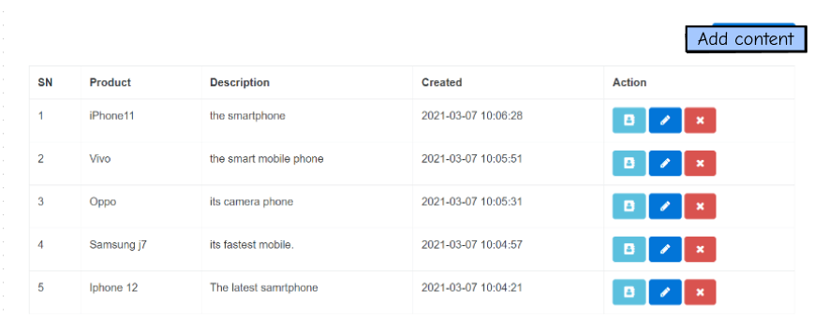
Screen | Content Management
Description | Allow Content Creator to manage CRUD of advertising content, products
Screen Access | Click on “Content list” in Content Creator's screen management page
Screen Content
Item |  | Type | Data |  | Description
Content List |  | Table |  |  | Content List
Add new content |  | Button |  |  | More content
See details |  | Button |  |  | Show detailed content
Edit content |  | Button |  |  | Edit content
Delete |  | Button |  |  | Delete content
Screen Actions
Action Name | Description |  |  | Success |  | Failure
Content List | This area displays the list of content already in the system.  Each asset is displayed with information like title, description, category, tags and content, etc.  Allow Content Creator to perform actions such as view details, modify or delete content |  |  | Show content list |  | When there is a database connection error -> Show the message “Failed to connect to the database".
Add new content | When a Content Creator clicks the "Create" button, the system will display an interface for Content Creator to enter details of his content.  Content Creator imports information like title, description, category, tags and content, and more.  After Content Creators finish entering information, they can press the "Save" button to save the added content. |  |  | Return to the page displaying the content list and the message: Edit successful. |  | When there is a database connection error -> Show the message “Failed to connect to the database".  The screen still shows the current page.
See details | When a Content Creator selects an asset from the list of assets and clicks View details, the system displays detailed information of each asset item, including title, description, category, tags, and content. |  |  | Display detailed information on each content item, including title, description, category, tags, and content. |  | When there is a database connection error -> Show the message “Failed to connect to the database".  The screen still shows the current page.
Sửa đổi | The Content Creator selects a specific content item and accesses the editing interface of that item. They can make changes to various fields such as title, description, category, tags, and content. They can also upload new media files or modify existing files. |  |  | The content item is updated with new changes, which will replace the previous version in the database or content storage repository. |  | When there is a database connection error -> Show the message “Failed to connect to the database".  The screen still shows the current page.
Xóa | When the Content Creator wants to delete a content item, they select a content item from the content list and click on the "Delete" button. |  |  | The system will display a confirmation window to confirm the deletion of the content. |  | When there is a database connection error -> Show the message “Failed to connect to the database".  The screen still shows the current page.

6.4 Shipper

6.4.1 Login
Screen | Log in
Description | Allow users to log in for a store account.
Screen Access | Click on the registration and login icon on the homepage of the shop website.
Screen Content
Item |  | Type | Data |  | Description
Username |  | Text field – String (50) |  |  | Enter the username field
Password |  | Text field – String (50) |  |  | Enter the password field
Login |  | Button |  |  | Login account to the shop's system.
Google login |  | Button |  |  | Sign up with a google account
Screen Actions
Action Name | Description |  |  | Success |  | Failure
Username | The user enters the account username to log in to an account in the shop. |  |  | Enter successfully. |  | If the user leaves this field blank, it will return a message asking the user to enter it.
Password | The user enters the account password to log in to an account in the shop. |  |  | Enter successfully. |  | If the user leaves this field blank, it will return a message asking the user to enter it.
Log in | This is the button to confirm the account login at the shop. |  |  | Display a successful registration message. |  | When the user enters incomplete fields, a message will be displayed asking the user to enter the fields that have not been documented.  If the user enters the wrong password or username, a message will be displayed asking the user to enter the correct username and password of the login name.
Google login | Login with a Google account. |  |  | Display the login page with Google and confirm the login account |  | If the logged-in Gmail has not registered an account in the shop's database, it will display a message that Gmail is not registered and ask the user to log in with another Google account.

6.4.2 Logout
Screen | Log out
Description | The user wants to log out of account on the store's website
Screen Access | Click on the login icon on the homepage of the shop website.
Screen Content
Item |  | Type | Data |  | Description
Account information |  | Button |  |  | User's account information
Logout |  | Button |  |  | Log out account
Screen Actions
Action Name | Description |  |  | Success |  | Failure
Account information | Show all user information |  |  | Successfully. |  | System error cannot be displayed
Logout | The user wants to log out of the shop's website system. |  |  | Logout successfully. |  | System error cannot be displayed

6.4.3 Change password
Screen | Change password
Description | The user wants to change the password.
Screen Access | Click on the profile account icon and select my account, and continue to select change password.
Screen Content
Item |  | Type | Data |  | Description
Old password |  | Text field – String (50) |  |  | Requires the user's old password.
New password |  | Text field – String (50) |  |  | Requires the user's new password.
Confirm new password |  | Text field – String (50) |  |  | Requires the user to re-enter the correct new password
Save |  | Button |  |  | Confirm to save updated password information
Screen Actions
Action Name | Description |  |  | Success |  | Failure
Old password | The user enters the old password registered for the shop account, this is a required field |  |  | Enter successful |  | If this field is left blank, a message will be displayed asking the user to enter  If the user does not enter the correct old password, a message will appear asking the user to enter the correct password registered at the shop's website.
New password | Enter the new password that the user wants to change the old password registered for the shop account, this is a required field |  |  | Enter successful |  | If this field is left blank, a message will be displayed asking the user to enter  Requires enter using password forma
Confirm new password | Confirm the password you want to change |  |  | Enter successful |  | If this field is left blank, a message will be displayed asking the user to enter  When the user enters the confirmation password, enter the correct new password that the user wants to change
Save | Save update new password for account |  |  | New password saved successfully |  | When the user enters the missing field, a message will be displayed asking the user to enter all information  Request enter the correct old password and confirm the correct new password

6.4.4 Forgot password

Screen | Forgot password
Description | User forgot password
Screen Access | Click on the login icon and continue to click on Forgot password
Screen Content
Item |  | Type | Data |  | Description
Forgot password |  | Button |  |  | The user forgot the shop's account password
Reset Password |  | Button |  |  | Change the password that the customer has forgotten
Enter email or username |  | Text field – String (50) |  |  | New password will be sent via registered email
Screen Actions
Action Name | Description |  |  | Success |  | Failure
Forgot password | The user forgot the password of the shop's website account and wants to recover the password |  |  | Information Confirmation: Users enter their username or email and click "Reset password." The system verifies if the entered information matches any account in the system. If the information is valid, the password recovery process continues. Password Reset Link: A password reset email containing a unique link is sent to the provided email address. The link typically has a limited validity period, such as 24 hours, to ensure security. Users need to check their inbox, access the email, and click the password reset link. Password  -After confirming, an email message has been sent and asks the user to confirm |  | A message appears in the upper corner of the screen when entering an exception "Please re-enter the field"
Reset Password | The final step to change the password when the customer forgets the old account after clicking on the confirmation link in the mail. |  |  | - Reset Page: Clicking the password reset link redirects users to a dedicated password reset page. This page prompts users to enter a new password. Sometimes, the system may also require users to confirm the new password by re-entering it. This ensures accuracy when setting a new password. New Password Confirmation: After entering and confirming the new password, users are directed to a confirmation page. This page informs users that their password has been successfully reset and provides instructions on using the new password to log in. |  | A message appears in the upper corner of the screen when entering an exception "Please re-enter the field"

6.4.5 View personal information
Screen | Personal information management
Description | Allow users to view registered personal information
Screen Access | Click on the link “Personal information” to go to the screen
Screen Content
Item |  | Type | Data |  | Description
User name |  | Text-nvarchar(50) |  |  | Display the user's username
Email |  | Text-nvarchar(50) |  |  | Show user's email
Fullname |  | Text-nvarchar(50) |  |  | Display the user's full name
Phone |  | Text-nvarchar(50) |  |  | Display the user's phone number
Address |  | Text-nvarchar(50) |  |  | Display the user's address
Screen Actions
Action Name | Description |  |  | Success |  | Failure
Change | When selecting "Change", the system will switch to the function of updating customer information |  |  | Go to the customer information edit page |  | When there is a database connection error -> Show the message “Failed to connect to the database".  The screen still shows the current page.

6.4.6 Update personal information
Screen | Change details of customer information
Description | Allow customers to change the information declared when registering
Screen Access | Click on the user icon in the top right corner
Screen Content
Item |  | Type | Data |  | Description
User name |  | Text-nvarchar(50) |  |  | Display the user's username
Email |  | Text-nvarchar(50) |  |  | Show user's email
Fullname |  | Text-nvarchar(50) |  |  | Display the user's full name
Phone |  | Text-nvarchar(50) |  |  | Display the user's phone number
Address |  | Text-nvarchar(50) |  |  | Hiển thị địa chỉ của người dùng
User name |  | Text-nvarchar(50) |  |  | Display the user's username
Email |  | Text-nvarchar(50) |  |  | Show user's email
Screen Actions
Action Name | Description |  |  | Success |  | Failure
Save | When the user selects "Save", the system checks the conditions and modifies the data of the selected edited data in the database. |  |  | Return to the home page and notice: Edit successful. |  | Display edited fields with the wrong data type and notify the screen if an error occurs

6.4.7 Confirm order
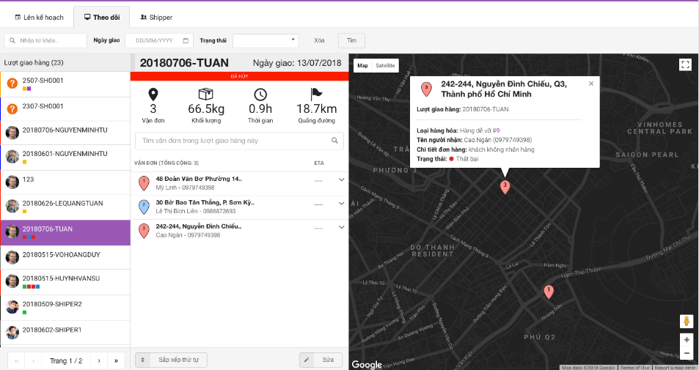
Screen | Display order information and order confirmation page
Description | The shipper will receive the order from the system and display the order information automatically, the shipper will confirm the order with the customer based on the information provided before proceeding with the delivery.
Screen Access | Click on “Undelivered orders” in the shipper screen, will display the order and then click on “Confirm order”
Screen Content
Item |  | Type | Data |  | Description
Customer name |  | Text field |  |  | Show customer name
Address |  | Text field |  |  | Show customer's address
Phone number |  | Text field |  |  | Show customer phone number
Product |  | Text field |  |  | Show product name in order
Quantity |  | Float |  |  | Show the quantity of each product in the order
Confirm |  | Button |  |  | Order confirmation
Screen Actions
Action Name | Description |  |  | Success |  | Failure
Confirm | When the shipper chooses to confirm, the order will update the status of "Confirmed" on the seller's side |  |  | Return to the list of orders to be delivered |  | When there is a database connection error -> Show the message “Failed to connect to the database".  The screen still shows the current page.

6.4.8 View order details
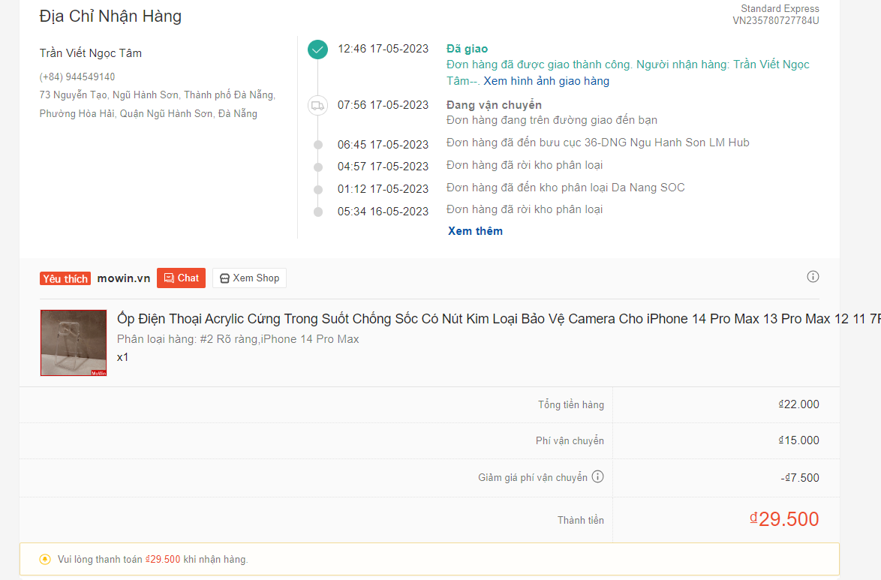
Screen | Order details display page
Description | Provide comprehensive information about a specific order, allowing shipper to track and process the order
Screen Access | Click on “View details” in the shipper's screen
Screen Content
Item |  | Type | Data |  | Description
Order ID |  | Alphanumeric ID |  |  | A unique identifier assigned to an order for reference and tracking purposes.
Customer name |  | Text field |  |  | Determine who ordered
Delivery address |  | Text field |  |  | Indicate where the order will be delivered
Payment address |  | Button |  |  | Represents the address associated with the payment for the order.
Order Items |  | Table |  |  | This section presents a tabular presentation of the items included in the purchase order. Tables typically include columns for item name, quantity, price per unit, and total cost per item. This information allows the shipper to verify the specific products and quantities included in the order and calculate the total cost.
Shipment details |  | Table |  |  | This section provides information regarding the shipping process. It includes the shipping method, indicating the selected shipping option, such as express or standard shipping. The estimated delivery date gives an approximate time frame for when the package is expected to arrive at its destination. In addition, a tracking number is provided, allowing the shipper or the customer to track the progress of the shipment.
Close (arrow back) |  | Button |  |  | Exit the detailed invoice view page
Screen Actions
Action Name | Description |  |  | Success |  | Failure
Close (arrow back) | When you click and mark the arrow, the screen will return to the homepage of the shipper screen, and finish viewing the order details. |  |  | Return to home page of shipper screen |  | When there is a database connection error -> Show the message “Failed to connect to the database".  The screen still shows the current page.

6.4.9 Confirm delivery
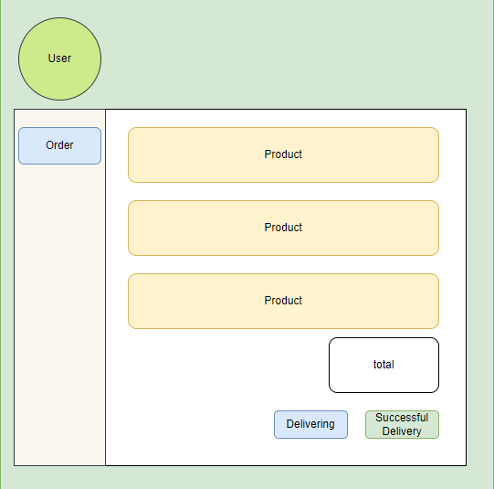
Screen | Display order information page for shipper to confirm delivery
Description | Shipper will press the delivery confirmation button before shipping
Screen Access | Click on Order in transit and click Confirm delivery
Screen Content
Item |  | Type | Data |  | Description
Order ID |  | Alphanumeric ID |  |  | A unique identifier assigned to an order for reference and tracking purposes.
Customer name |  | Text field |  |  | Determine who ordered
Delivery address |  | Text field |  |  | Indicate where the order will be delivered
Payment address |  | Button |  |  | Represents the address associated with the payment for the order.
Order Items |  | Table |  |  | This section presents a tabular presentation of the items included in the purchase order. Tables typically include columns for item name, quantity, price per unit, and total cost per item. This information allows the shipper to verify the specific products and quantities included in the order and calculate the total cost.
Shipment details |  | Table |  |  | This section provides information regarding the shipping process. It includes the shipping method, indicating the selected shipping option, such as express or standard shipping. The estimated delivery date gives an approximate time frame for when the package is expected to arrive at its destination. In addition, a tracking number is provided, allowing the shipper or the customer to track the progress of the shipment.
Close (arrow back) |  | Button |  |  | Exit the detailed invoice view page
Confirm |  | Button |  |  | When the shipper clicks  this button, this action usually triggers the necessary updates in the system, marks the shipment as confirmed delivered by the shipper, updates tracking information
Screen Actions
Action Name | Description |  |  | Success |  | Failure
Close (arrow back) | When you click and mark the arrow, the screen will return to the homepage of the shipper screen, finish viewing the delivery confirmation |  |  | Return to home page of shipper screen |  | When there is a database connection error -> Show the message “Failed to connect to the database".  The screen still shows the current page.
Confirm | When the shipper clicks this button, this action usually triggers the necessary updates in the system, marking the shipment as confirmed delivered by the shipper, updating the tracking information. |  |  | Return to home page of shipper screen |  | When there is a database connection error -> Show the message “Failed to connect to the database".  The screen still shows the current page.

6.4.10 Check failed delivery
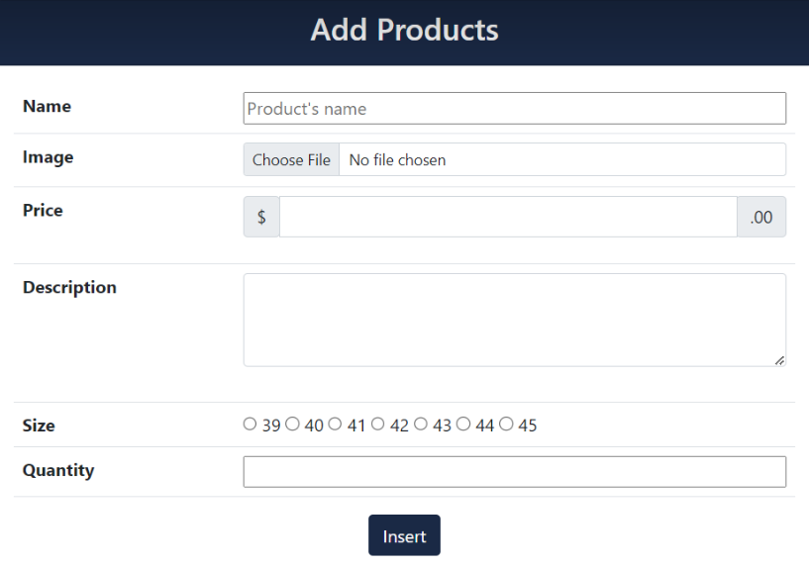
Screen | Trang chỉnh sửa trạng thái đơn hàng của Shipper
Description | Allow the Shipper to change the status of the order being delivered to failure
Screen Access | Click on the status box of the order and select “Delivery Failed”
Screen Content
Item |  | Type | Data |  | Description
Order |  | ComboBox |  |  | Select order
Order Status |  | Select |  |  | Select the status of the order
Save |  | Button |  |  | Save order status
Screen Actions
Action Name | Description |  |  | Success |  | Failure
Order Status | When the user selects the order status box, the system will display a list of order statuses for the Shipper to choose from. |  |  | Displays a list of order statuses. |  | When there is a database connection error -> Show the message “Failed to connect to the database".  The screen still shows the current page.
Save | When the user selects Save, the system will save the edits and modify the data in the database. |  |  | The order status box will change to “delivery failed” . |  | When there is a database connection error -> Show the message “Failed to connect to the database".  The screen still shows the current page.

6.4.11 View detail order history
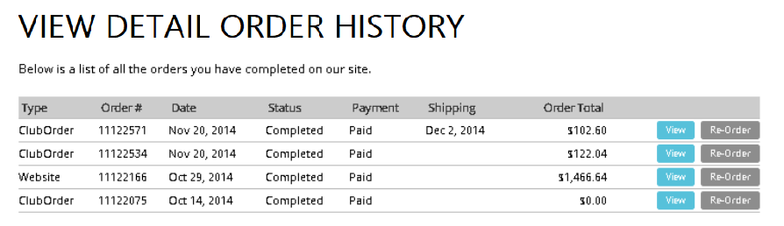
Screen | View detailed order history
Description | Allows users to view details of order history.
Screen Access | Click on “Order History Details” in the Order page.
Screen Content
Item |  | Type | Data |  | Description
Order List |  | Table |  |  | Order list display table
See details |  | Button |  |  | View details of delivered orders
Screen Actions
Action Name | Description |  |  | Success |  | Failure
See details | When the user selects an order from the list of delivered orders and clicks View details, the system will display the details of that order.  Displays information such as order ID, order date, order status (delivered), etc.  Display information about products/products in the order, including product name, price, quantity, etc.  Display customer information, including customer name, address, phone number, etc.  Display shipping information, including carrier information, waybill number, etc. |  |  | Display detailed information about the order. |  | When there is a database connection error -> Show the message “Failed to connect to the database".  The screen still shows the current page.

6.5 Seller

6.5.1 Log in

Screen | Log in
Description | Allow users to log in for a store account.
Screen Access | Click on the registration and login icon on the homepage of the shop website.
Screen Content
Item |  | Type | Data |  | Description
Username |  | Text field – String (50) |  |  | Enter the username field
Password |  | Text field – String (50) |  |  | Enter the password field
Login |  | Button |  |  | Login account to the shop's system.
Google login |  | Button |  |  | Sign up with a google account
Screen Actions
Action Name | Description |  |  | Success |  | Failure
Username | The user enters the account username to log in to an account in the shop. |  |  | Enter successfully. |  | If the user leaves this field blank, it will return a message asking the user to enter it.
Password | The user enters the account password to log in to an account in the shop. |  |  | Enter successfully. |  | If the user leaves this field blank, it will return a message asking the user to enter it.
Log in | This is the button to confirm the account login at the shop. |  |  | Display a successful registration message. |  | When the user enters incomplete fields, a message will be displayed asking the user to enter the fields that have not been documented.  If the user enters the wrong password or username, a message will be displayed asking the user to enter the correct username and password of the login name.
Google login | Login with a Google account. |  |  | Display the login page with Google and confirm the login account |  | If the logged-in Gmail has not registered an account in the shop's database, it will display a message that Gmail is not registered and ask the user to log in with another Google account.

6.5.2 Log out
Screen | Log out
Description | The user wants to log out of account on the store's website
Screen Access | Click on the login icon on the homepage of the shop website.
Screen Content
Item |  | Type | Data |  | Description
Account information |  | Button |  |  | User's account information
Logout |  | Button |  |  | Log out account
Screen Actions
Action Name | Description |  |  | Success |  | Failure
Account information | Show all user information |  |  | Successfully. |  | System error cannot be displayed
Logout | The user wants to log out of the shop's website system. |  |  | Logout successfully. |  | System error cannot be displayed

6.5.3 Change password
Screen | Change password
Description | The user wants to change the password.
Screen Access | Click on the profile account icon and select my account, and continue to select change password.
Screen Content
Item |  | Type | Data |  | Description
Old password |  | Text field – String (50) |  |  | Requires the user's old password.
New password |  | Text field – String (50) |  |  | Requires the user's new password.
Confirm new password |  | Text field – String (50) |  |  | Requires the user to re-enter the correct new password
Save |  | Button |  |  | Confirm to save updated password information
Screen Actions
Action Name | Description |  |  | Success |  | Failure
Old password | The user enters the old password registered for the shop account, this is a required field |  |  | Enter successful |  | If this field is left blank, a message will be displayed asking the user to enter  If the user does not enter the correct old password, a message will appear asking the user to enter the correct password registered at the shop's website.
New password | Enter the new password that the user wants to change the old password registered for the shop account, this is a required field |  |  | Enter successful |  | If this field is left blank, a message will be displayed asking the user to enter  Requires enter using password forma
Confirm new password | Confirm the password you want to change |  |  | Enter successful |  | If this field is left blank, a message will be displayed asking the user to enter  When the user enters the confirmation password, enter the correct new password that the user wants to change
Save | Save update new password for account |  |  | New password saved successfully |  | When the user enters the missing field, a message will be displayed asking the user to enter all information  Request enter the correct old password and confirm the correct new password

6.5.4 Forgot password

Screen | Forgot password
Description | User forgot password
Screen Access | Click on the login icon and continue to click on Forgot password
Screen Content
Item |  | Type | Data |  | Description
Forgot password |  | Button |  |  | The user forgot the shop's account password
Reset Password |  | Button |  |  | Change the password that the customer has forgotten
Enter email or username |  | Text field – String (50) |  |  | New password will be sent via registered email
Screen Actions
Action Name | Description |  |  | Success |  | Failure
Forgot password | The user forgot the password of the shop's website account and wants to recover the password |  |  | Information Confirmation: Users enter their username or email and click "Reset password." The system verifies if the entered information matches any account in the system. If the information is valid, the password recovery process continues. Password Reset Link: A password reset email containing a unique link is sent to the provided email address. The link typically has a limited validity period, such as 24 hours, to ensure security. Users need to check their inbox, access the email, and click the password reset link. Password  -After confirming, an email message has been sent and asks the user to confirm |  | A message appears in the upper corner of the screen when entering an exception "Please re-enter the field"
Reset Password | The final step to change the password when the customer forgets the old account after clicking on the confirmation link in the mail. |  |  | - Reset Page: Clicking the password reset link redirects users to a dedicated password reset page. This page prompts users to enter a new password. Sometimes, the system may also require users to confirm the new password by re-entering it. This ensures accuracy when setting a new password. New Password Confirmation: After entering and confirming the new password, users are directed to a confirmation page. This page informs users that their password has been successfully reset and provides instructions on using the new password to log in. |  | A message appears in the upper corner of the screen when entering an exception "Please re-enter the field"

6.5.5 View products
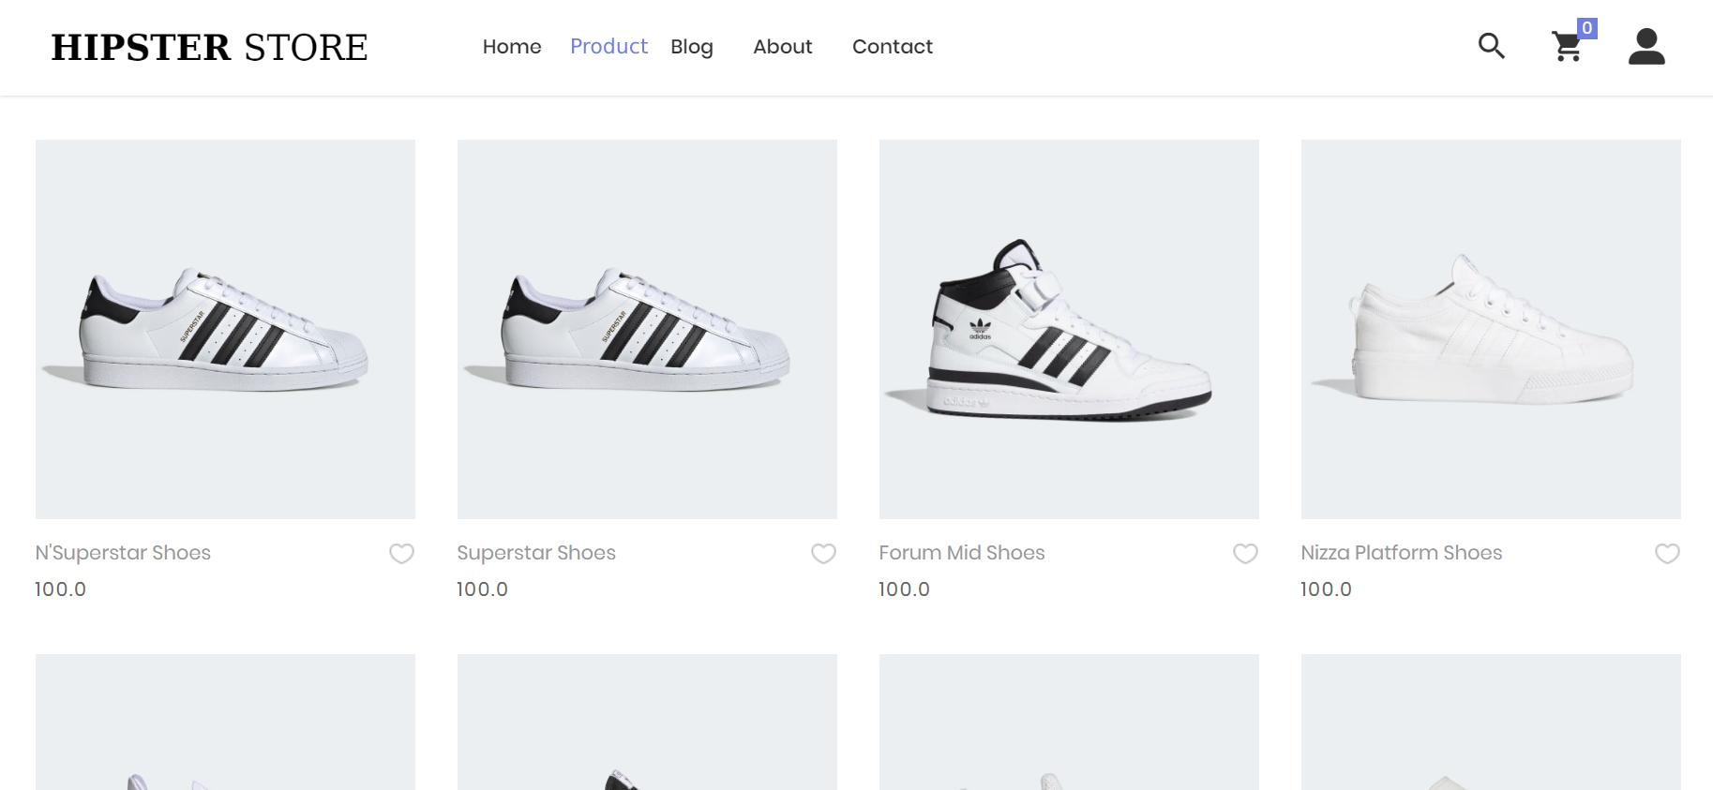

Screen | View products
Description | View the products of the shop
Screen Access | User visits the store's website and clicks on Products
Screen Content
Item |  | Type | Data |  | Description
Product |  | Button |  |  | View all products in the shop
Screen Actions
Action Name | Description |  |  | Success |  | Failure
Product | When the user clicks on the Product icon, a Product page will appear containing all the products in the shop's website |  |  | The system returns the product page |  | When there is a database connection error -> Show the message "Connection failed".  The screen still shows the current page.

6.5.6 Search product

Screen | Search products
Description | Search for products in the shop
Screen Access | User visits the store's website and clicks on Search
Screen Content
Item |  | Type | Data |  | Description
Search products |  | Button |  |  | Users want to search for products in the shop
Search |  | Text field – String (50) |  |  | Enter the product the user wants to search for
Screen Actions
Action Name | Description |  |  | Success |  | Failure
Search products | Users click on the search button icon to search for products in the shop |  |  | The system will return an Alerts message, for the user to enter the product to look for |  | System error cannot be displayed  Description of left blank will re-describe the old description.
Search | The user will enter the product they want to find on the shop's website |  |  | Returns displays the product the person wants to search for |  | Product not found error

6.5.7 CRUD products
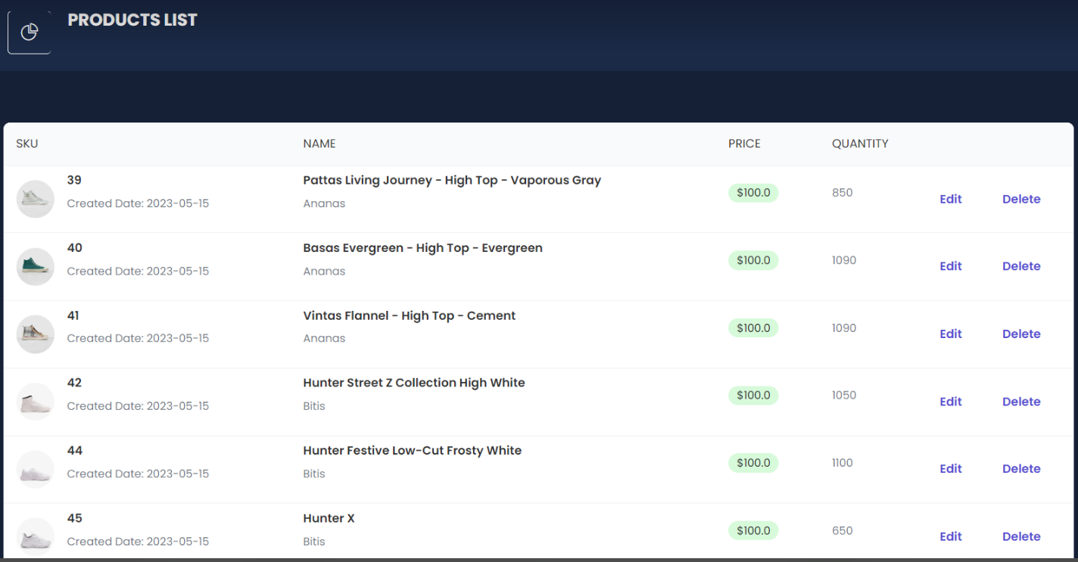

Screen | Product CRUD edit page.
Description | Allow Seller and Admin to CRUD products
Screen Access | Click on the “Products” box in the management interface.
Screen Content
Item |  | Type | Data |  | Description
Product's name |  | Text field – String (50) |  |  | Product name edit box
Product information |  | Text field – String |  |  | Product information box
Price |  | int |  |  | Price edit box
Save |  | Button |  |  | Save new product information
Cancel |  | Button |  |  | Cancel the action
Erase |  | Button |  |  | Delete product
Screen Actions
Action Name | Description |  |  | Success |  | Failure
Save | When the user selects Save, the system will check the conditions and modify the data of the selected topic in the database. |  |  | Update the product list and display the message: "Product created successfully." |  | If the product name is blank or is the same as another product name, display the corresponding message.  If the product price is not valid, display the message: "Invalid product price."
Cancel | When you select Cancel, the system does not accept any action on this page. |  |  | The system does not save any changes and returns to the original state. |  | When there is a database connection error -> Show the message “Failed to connect to the database".  The screen still shows the current page.
Erase | When selecting delete, the system will display a popup asking if you are sure you want to delete the product |  |  | Show popup page  If the deletion is successful, update the product list and display the message: "Product has been successfully deleted." |  | When there is a database connection error -> Show the message “Failed to connect to the database".  The screen still shows the current page.

6.5.8 View order status
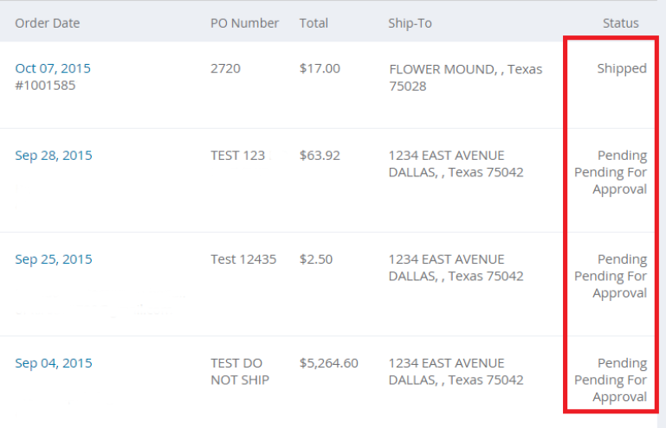
Screen | Show order status
Description | Allows users to view row menu status.
Screen Access | Click the icon in the “Place Order” page interface.
Screen Content
Item |  | Type | Data |  | Description
Code orders |  | Text field – String (50) |  |  | Show the menu code
View status |  | Button |  |  | View order status
Customer information |  | Text field – String |  |  | Show customer information
Order Status |  | Text field – String |  |  | Order status display area
Screen Actions
Action Name | Description |  |  | Success |  | Failure
Code orders | Displays the user's order number. |  |  | Display the order number on the screen. |  | When there is a database connection error -> Show the message “Failed to connect to the database".  The screen still shows the current page.
Customer information | Display information such as customer name, address, phone number. |  |  | Display customer information. |  | When there is a database connection error -> Show the message “Failed to connect to the database".  The screen still shows the current page.
Order Status | Display information such as order status, order date, estimated delivery date |  |  | Show order status |  | When there is a database connection error -> Show the message “Failed to connect to the database".  The screen still shows the current page.

6.5.9 View sale history
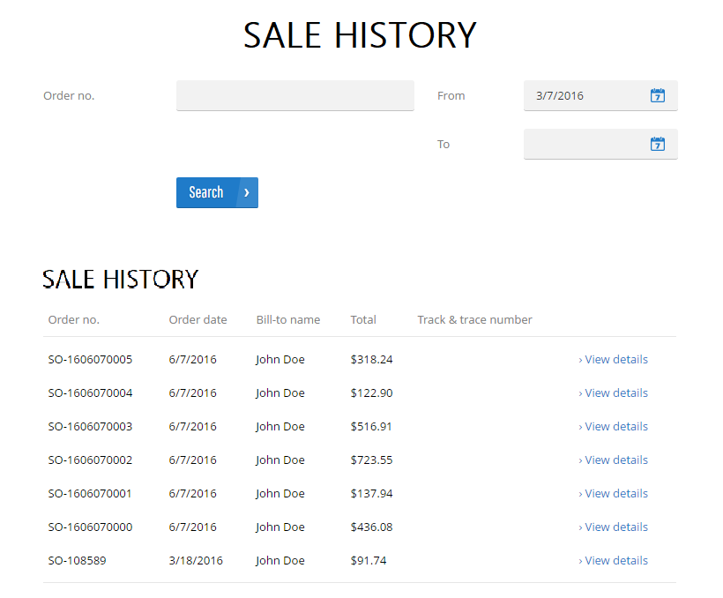

Screen | Page showing sales history
Description | Allow Seller and Admin to view the store's sales history
Screen Access | Click on “Sale History” in the management page.
Screen Content
Item |  | Type | Data |  | Description
Since |  | DATE |  |  | Start date selector box
To date |  | DATE |  |  | End date selection box
View history |  | Button |  |  | View history
Order List |  | Table |  |  | Order list display table
Screen Actions
Action Name | Description |  |  | Success |  | Failure
View history | When the user selects a start and end date, and then clicks View history, the system will query the database to get information about orders for the selected time period. |  |  | Displays a list of orders corresponding to the selected start and end date. |  | When there is a database connection error -> Show the message “Failed to connect to the database".  The screen still shows the current page.
Order List | This area displays a list of orders that were sold during the selected time period.  Each order will be displayed with information such as order number, order date, order status, etc.  Allows users to view each order details and related information. |  |  | Show list of orders that have been sold |  | When there is a database connection error -> Show the message “Failed to connect to the database".  The screen still shows the current page.

6.5.10 View revenue statistic table
Screen | View revenue statistics table
Description | Let Seller and Admin see the store's sales statistics.
Screen Access | Click on “View revenue” in the management page.
Screen Content
Item |  | Type | Data |  | Description
Start date |  | DATE |  |  | Start date selector box
End date |  | DATE |  |  | End date selection box
View stats |  | Button |  |  | View stats
Revenue statistics table |  | Table |  |  | Statistics display table
Screen Actions
Action Name | Description |  |  | Success |  | Failure
View stats | When the user selects a start and end date, and then clicks View Statistics, the system will query the database to get information about the revenue for the selected period. |  |  | Display revenue statistics table based on collected information. |  | When there is a database connection error -> Show the message “Failed to connect to the database".  The screen still shows the current page.
Revenue statistics table | This area shows the revenue statistics table for the selected period.  The statistics table has columns like date, revenue, number of orders, etc.  Displays detailed statistical information about daily revenue. |  |  | Show revenue statistics table |  | When there is a database connection error -> Show the message “Failed to connect to the database".  The screen still shows the current page.

6.6 Store Administrator

6.6.1 Log in

Screen | Log in
Description | Allow users to log in for a store account.
Screen Access | Click on the registration and login icon on the homepage of the shop website.
Screen Content
Item |  | Type | Data |  | Description
Username |  | Text field – String (50) |  |  | Enter the username field
Password |  | Text field – String (50) |  |  | Enter the password field
Login |  | Button |  |  | Login account to the shop's system.
Google login |  | Button |  |  | Sign up with a google account
Screen Actions
Action Name | Description |  |  | Success |  | Failure
Username | The user enters the account username to log in to an account in the shop. |  |  | Enter successfully. |  | If the user leaves this field blank, it will return a message asking the user to enter it.
Password | The user enters the account password to log in to an account in the shop. |  |  | Enter successfully. |  | If the user leaves this field blank, it will return a message asking the user to enter it.
Log in | This is the button to confirm the account login at the shop. |  |  | Display a successful registration message. |  | When the user enters incomplete fields, a message will be displayed asking the user to enter the fields that have not been documented.  If the user enters the wrong password or username, a message will be displayed asking the user to enter the correct username and password of the login name.
Google login | Login with a Google account. |  |  | Display the login page with Google and confirm the login account |  | If the logged-in Gmail has not registered an account in the shop's database, it will display a message that Gmail is not registered and ask the user to log in with another Google account.

6.6.2 Log out
Screen | Log out
Description | The user wants to log out of account on the store's website
Screen Access | Click on the login icon on the homepage of the shop website.
Screen Content
Item |  | Type | Data |  | Description
Account information |  | Button |  |  | User's account information
Logout |  | Button |  |  | Log out account
Screen Actions
Action Name | Description |  |  | Success |  | Failure
Account information | Show all user information |  |  | Successfully. |  | System error cannot be displayed
Logout | The user wants to log out of the shop's website system. |  |  | Logout successfully. |  | System error cannot be displayed

6.6.3 Change password
Screen | Change password
Description | The user wants to change the password.
Screen Access | Click on the profile account icon and select my account, and continue to select change password.
Screen Content
Item |  | Type | Data |  | Description
Old password |  | Text field – String (50) |  |  | Requires the user's old password.
New password |  | Text field – String (50) |  |  | Requires the user's new password.
Confirm new password |  | Text field – String (50) |  |  | Requires the user to re-enter the correct new password
Save |  | Button |  |  | Confirm to save updated password information
Screen Actions
Action Name | Description |  |  | Success |  | Failure
Old password | The user enters the old password registered for the shop account, this is a required field |  |  | Enter successful |  | If this field is left blank, a message will be displayed asking the user to enter  If the user does not enter the correct old password, a message will appear asking the user to enter the correct password registered at the shop's website.
New password | Enter the new password that the user wants to change the old password registered for the shop account, this is a required field |  |  | Enter successful |  | If this field is left blank, a message will be displayed asking the user to enter  Requires enter using password forma
Confirm new password | Confirm the password you want to change |  |  | Enter successful |  | If this field is left blank, a message will be displayed asking the user to enter  When the user enters the confirmation password, enter the correct new password that the user wants to change
Save | Save update new password for account |  |  | New password saved successfully |  | When the user enters the missing field, a message will be displayed asking the user to enter all information  Request enter the correct old password and confirm the correct new password

6.6.4 Forgot password

Screen | Forgot password
Description | User forgot password
Screen Access | Click on the login icon and continue to click on Forgot password
Screen Content
Item |  | Type | Data |  | Description
Forgot password |  | Button |  |  | The user forgot the shop's account password
Reset Password |  | Button |  |  | Change the password that the customer has forgotten
Enter email or username |  | Text field – String (50) |  |  | New password will be sent via registered email
Screen Actions
Action Name | Description |  |  | Success |  | Failure
Forgot password | The user forgot the password of the shop's website account and wants to recover the password |  |  | Information Confirmation: Users enter their username or email and click "Reset password." The system verifies if the entered information matches any account in the system. If the information is valid, the password recovery process continues. Password Reset Link: A password reset email containing a unique link is sent to the provided email address. The link typically has a limited validity period, such as 24 hours, to ensure security. Users need to check their inbox, access the email, and click the password reset link. Password  -After confirming, an email message has been sent and asks the user to confirm |  | A message appears in the upper corner of the screen when entering an exception "Please re-enter the field"
Reset Password | The final step to change the password when the customer forgets the old account after clicking on the confirmation link in the mail. |  |  | - Reset Page: Clicking the password reset link redirects users to a dedicated password reset page. This page prompts users to enter a new password. Sometimes, the system may also require users to confirm the new password by re-entering it. This ensures accuracy when setting a new password. New Password Confirmation: After entering and confirming the new password, users are directed to a confirmation page. This page informs users that their password has been successfully reset and provides instructions on using the new password to log in. |  | A message appears in the upper corner of the screen when entering an exception "Please re-enter the field"

6.6.5 View products

Screen | View products
Description | View the products of the shop
Screen Access | User visits the store's website and clicks on Products
Screen Content
Item |  | Type | Data |  | Description
Product |  | Button |  |  | View all products in the shop
Screen Actions
Action Name | Description |  |  | Success |  | Failure
Product | When the user clicks on the Product icon, a Product page will appear containing all the products in the shop's website |  |  | The system returns the product page |  | When there is a database connection error -> Show the message "Connection failed".  The screen still shows the current page.

6.6.6 Search products

Screen | Search products
Description | Search for products in the shop
Screen Access | User visits the store's website and clicks on Search
Screen Content
Item |  | Type | Data |  | Description
Search products |  | Button |  |  | Users want to search for products in the shop
Search |  | Text field – String (50) |  |  | Enter the product the user wants to search for
Screen Actions
Action Name | Description |  |  | Success |  | Failure
Search products | Users click on the search button icon to search for products in the shop |  |  | The system will return an Alerts message, for the user to enter the product to look for |  | System error cannot be displayed  Description if left blank will re-describe the old description.
Search | The user will enter the product they want to find on the shop's website |  |  | Returns displays the product the person wants to search for |  | Product not found error

6.6.7 CRUD products
Screen | Product CRUD edit page.
Description | Allow Seller and Admin to CRUD products
Screen Access | Click on the “Products” box in the management interface.
Screen Content
Item |  | Type | Data |  | Description
Product's name |  | Text field – String (50) |  |  | Product name edit box
Product information |  | Text field – String |  |  | Product information box
Price |  | int |  |  | Price edit box
Save |  | Button |  |  | Save new product information
Cancel |  | Button |  |  | Cancel the action
Erase |  | Button |  |  | Delete product
Screen Actions
Action Name | Description |  |  | Success |  | Failure
Save | When the user selects Save, the system will check the conditions and modify the data of the selected topic in the database. |  |  | Update the product list and display the message: "Product created successfully." |  | If the product name is blank or is the same as another product name, display the corresponding message.  If the product price is not valid, display the message: "Invalid product price."
Cancel | When you select Cancel, the system does not accept any action on this page. |  |  | The system does not save any changes and returns to the original state. |  | When there is a database connection error -> Show the message “Failed to connect to the database".  The screen still shows the current page.
Erase | When selecting delete, the system will display a popup asking if you are sure you want to delete the product |  |  | Show popup page  If the deletion is successful, update the product list and display the message: "Product has been successfully deleted." |  | When there is a database connection error -> Show the message “Failed to connect to the database".  The screen still shows the current page.

6.6.8 View order status
Screen | Show order status
Description | Allows users to view row menu status.
Screen Access | Click the icon in the “Place Order” page interface.
Screen Content
Item |  | Type | Data |  | Description
Code orders |  | Text field – String (50) |  |  | Show the menu code
View status |  | Button |  |  | View order status
Customer information |  | Text field – String |  |  | Show customer information
Order Status |  | Text field – String |  |  | Order status display area
Screen Actions
Action Name | Description |  |  | Success |  | Failure
Code orders | Displays the user's order number. |  |  | Display the order number on the screen. |  | When there is a database connection error -> Show the message “Failed to connect to the database".  The screen still shows the current page.
Customer information | Display information such as customer name, address, phone number. |  |  | Display customer information. |  | When there is a database connection error -> Show the message “Failed to connect to the database".  The screen still shows the current page.
Order Status | Display information such as order status, order date, estimated delivery date |  |  | Show order status |  | When there is a database connection error -> Show the message “Failed to connect to the database".  The screen still shows the current page.

6.6.9 View sale history
Screen | Page showing sales history
Description | Allow Seller and Admin to view the store's sales history
Screen Access | Click on “Sale History” in the management page.
Screen Content
Item |  | Type | Data |  | Description
Since |  | DATE |  |  | Start date selector box
To date |  | DATE |  |  | End date selection box
View history |  | Button |  |  | View history
Order List |  | Table |  |  | Order list display table
Screen Actions
Action Name | Description |  |  | Success |  | Failure
View history | When the user selects a start and end date, and then clicks View history, the system will query the database to get information about orders for the selected time period. |  |  | Displays a list of orders corresponding to the selected start and end date. |  | When there is a database connection error -> Show the message “Failed to connect to the database".  The screen still shows the current page.
Order List | This area displays a list of orders that were sold during the selected time period.  Each order will be displayed with information such as order number, order date, order status, etc.  Allows users to view each order details and related information. |  |  | Show list of orders that have been sold |  | When there is a database connection error -> Show the message “Failed to connect to the database".  The screen still shows the current page.

6.6.10 View revenue

Screen | View revenue statistics table
Description | Let Seller and Admin see the store's sales statistics.
Screen Access | Click on “View revenue” in the management page.
Screen Content
Item |  | Type | Data |  | Description
Since |  | DATE |  |  | Start date selector box
To date |  | DATE |  |  | End date selection box
View stats |  | Button |  |  | View stats
Revenue statistics table |  | Table |  |  | Statistics display table
Screen Actions
Action Name | Description |  |  | Success |  | Failure
View stats | When the user selects a start and end date, and then clicks View Statistics, the system will query the database to get information about the revenue for the selected period. |  |  | Display revenue statistics table based on collected information. |  | View detailed order history  Allows users to view details of order history.  Click on “Order History Details” in the Order page.
Revenue statistics table | This area shows the revenue statistics table for the selected period.  The statistics table has columns like date, revenue, number of orders, etc.  Displays detailed statistical information about daily revenue. |  |  | Show revenue statistics table |  | When there is a database connection error -> Show the message “Failed to connect to the database".  The screen still shows the current page.  When there is a database connection error -> Show the message “Failed to connect to the database".  The screen still shows the current page.

6.6.11 View detail order history

Screen | View detailed order history
Description | Allows users to view details of order history.
Screen Access | Click on “Order History Details” in the Order page.
Screen Content
Item |  | Type | Data |  | Description
Order List |  | Table |  |  | Order list display table
See details |  | Button |  |  | View details of delivered orders
Screen Actions
Action Name | Description |  |  | Success |  | Failure
View detail | When the user selects an order from the list of delivered orders and clicks View details, the system will display the details of that order.  Displays information such as order ID, order date, order status (delivered), etc.  Display information about products/products in the order, including product name, price, quantity, etc.  Display customer information, including customer name, address, phone number, etc.  Display shipping information, including carrier information, waybill number, etc. |  |  | Display detailed information about the order. |  | When there is a database connection error -> Show the message “Failed to connect to the database".  The screen still shows the current page.

6.6.12 CRUD employees
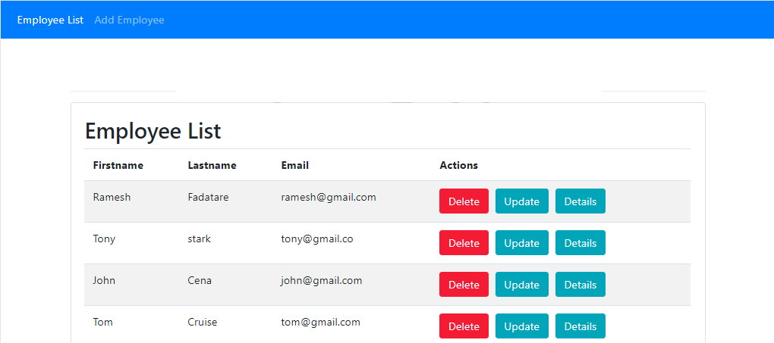
Screen | Employee manager
Description | Allows Admin to manage CRUD of employees in the store.
Screen Access | Click on “Employee Manager” in the management page.
Screen Content
Item |  | Type | Data |  | Description
List of employee |  | Table |  |  | List of employees in the store
More staff |  | Button |  |  | Add new staff
See details |  | Button |  |  | Show employee information
Revision |  | Button |  |  | Edit employee information
Remove |  | Button |  |  | Delete employee
Screen Actions
Action Name | Description |  |  | Success |  | Failure
List of employee | This area displays the list of employees already in the system.  Each employee is displayed with information such as name, title, address, phone number, etc.  Allows Admin to perform actions such as view details, modify or delete employee information. |  |  | Displays a list of employees. |  | When there is a database connection error -> Show the message “Failed to connect to the database".  The screen still shows the current page.
Add Employee | When the user clicks the "Add employee" button, the system will display an interface for the user to enter the information of the new employee.  User enters information such as name, position, address, phone number, etc.  After the user finishes entering the information, they can press the "Save" button to save the new employee information into the system. |  |  | Return to the page displaying the list of employees and the message: Edit successful. |  | When there is a database connection error -> Show the message “Failed to connect to the database".  The screen still shows the current page.
See details | When the Admin selects an employee from the list of employees and clicks View details, the system will display the details of that employee. |  |  | Displays information such as name, title, address, phone number, etc.  Users can view and edit employee details. |  | When there is a database connection error -> Show the message “Failed to connect to the database".  The screen still shows the current page.
Revision | When the Admin selects an employee from the list of employees and clicks Edit, the system will allow the user to edit the details of that employee.  Admin can change information such as name, position, address, phone number, etc.  After the user finishes modifying the information, he or she can press the "Save" button to update the employee information in the system. |  |  | Display the message "Edit successful" and update employee information again. |  | When there is a database connection error -> Show the message “Failed to connect to the database".  The screen still shows the current page.
Remove | When the Admin wants to delete an employee: select an employee from the list of employees and press Delete |  |  | The system will display a confirmation window to confirm the deletion of the employee. |  | When there is a connection error  database connection -> Display the message “Failed to connect to the database”.  The screen still shows the current page.

7. NON-FUNCTIONAL REQUIREMENTS AND OTHERS

Performance
No. | Requirement
1. | Fast response time
2. | Fast data import/export time

Scalability
No. | Requirement
1. | Large data storage capacity
2. | Allows multiple users to perform the same operations in the same amount of time

Security
No. | Requirement
2. | Log in to perform functions corresponding to each user's role
3. | Log in to perform functions corresponding to each user's role

Browser
No. | Requirement
1. | IE6 and above (IE8 is not recommended).
2. | Chrome and Firefox

Reliability
No. | Requirement
1. | If there is a problem, the system recovery time (from backed up data) is within 1 day.

Interfaces
No. | Requirement
1. | Using Bootstrap 4 library, Jquery to create interface

Assumptions
No. | Requirement
1. | Can suspend the system if need to upgrade

